3-Bean Salad

Makes: 6 servings (1 cup per serving)
Preparation Time: 6 to 10 minutes

Ingredients
1 (14.5 ounce) can green beans, drained and rinsed
1 (15 ounce) can pinto or garbanzo beans, drained and rinsed
1 (15 ounce) can kidney beans, drained and rinsed
½ green pepper, chopped
2 teaspoons sugar
6 tablespoons apple cider vinegar
3 tablespoons vegetable oil
¼ teaspoon black pepper
¼ teaspoon salt (optional)

Directions
- Before starting to prepare the recipe:
  - Wash the green pepper.
  - Collect, chop, and measure all ingredients.
  - Open, drain, and rinse the beans.
- Mix the green beans, pinto or garbanzo beans, kidney beans, and green pepper in a large bowl.
- In a small bowl, mix the sugar, vinegar, oil, and black pepper. Pour the liquid mixture over the beans and green pepper, and toss together.
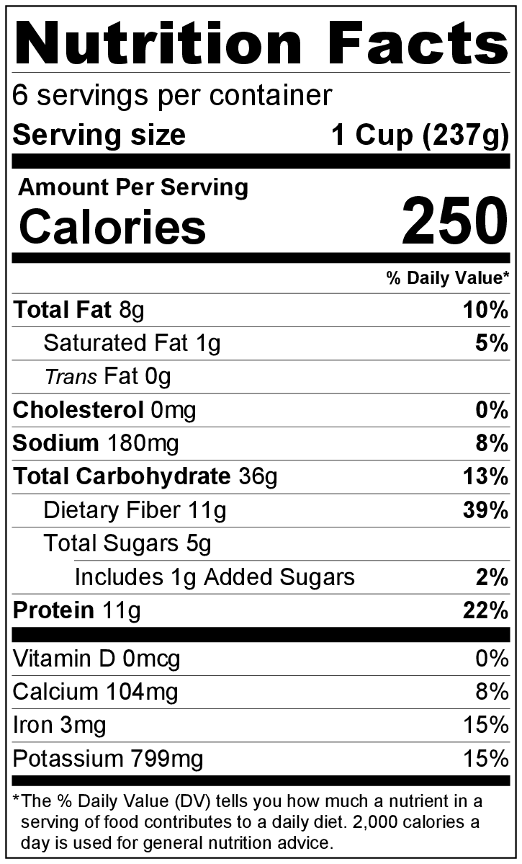
- Taste, and add salt if desired.
- Serve immediately, or chill overnight for even better flavor.
- Refrigerate leftovers within 2 hours. Eat within 3 to 5 days.

Be creative! Try adding minced onions, other vegetables, or cooked pasta.

