Baked Tortilla Chips

Makes: 6 servings (4 chips per serving)
Preparation Time: 5 minutes
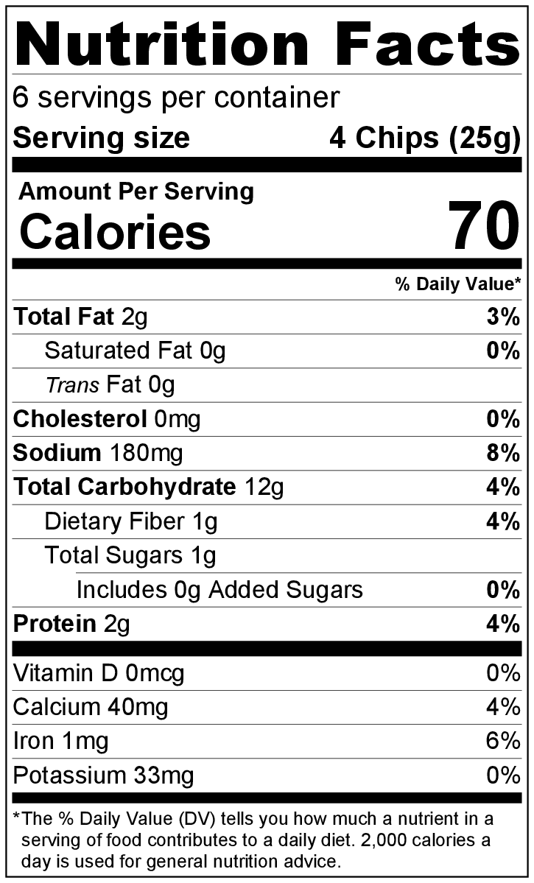
Cooking Time: 10 minutes
White Flour Tortillas

Ingredients
Nonstick cooking spray
3 (10 inch) corn, whole wheat flour, or white flour tortillas
Salt

Directions
- Preheat oven to 400°F.
- Collect all ingredients before starting to prepare the recipe.
- Lightly spray a baking sheet with cooking spray.
- Cut tortillas into 8 sections each (as if you were cutting a pizza), and place in a single layer on the baking sheet.
- Spray tops of tortillas with cooking spray, and lightly sprinkle with a small amount of salt.
- Bake for 8 to 10 minutes or until crisp and light brown.
Watch closely so the chips don’t burn.
- Cool for a few minutes after taking out of the oven before serving.
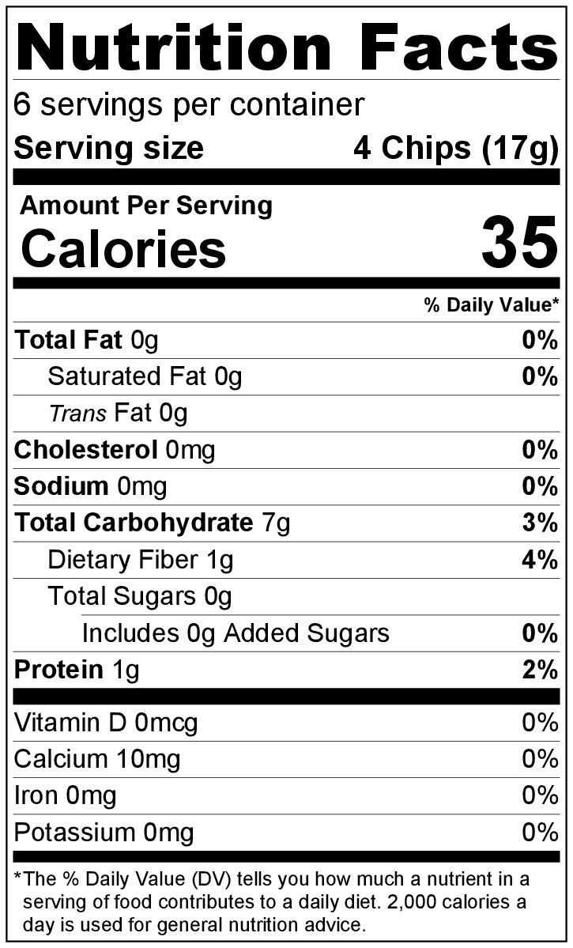
- Store in an airtight container on the counter for 3 to 5 days.
Corn Tortillas
Reheat in the oven.

Be creative! Serve with Mango Salsa or Zesty Bean Dip from the Eating Smart • Being Active Let’s Cook! cookbook or other salsas, dips, soups, or salads.

