Beef and Potatoes

Makes: 7 servings (1 cup per serving)
Preparation Time: 5 minutes
Cooking Time: 25 to 35 minutes

Ingredients
1 pound ground beef
1 ⅓ cup water
6 to 8 medium potatoes, peeled and thinly sliced
¾ cup Eating Smart Seasoning Mix from the Eating Smart • Being Active Let’s Cook! cookbook*
Salt, to taste

Directions
- Wash and peel the potatoes.
- Collect, slice, and measure all ingredients before starting to prepare the recipe.
- Brown ground beef in a large skillet. Remove the skillet from the heat. Remove excess fat by pushing the beef to one side, then tilting the skillet in the opposite direction so the liquid fat pools away from the beef. Use a large spoon to remove the liquid fat from the pan. Discard the fat in the trash can.
- Put the skillet back on the heat. Add water, potatoes, and seasoning mix. Stir to combine with the beef.
- Bring to a boil, then reduce heat to low, cover, and simmer for 20 to 30 minutes or until potatoes are tender.
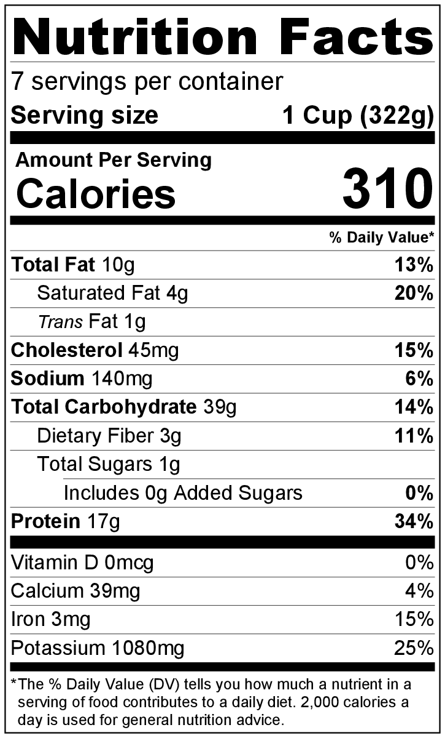
- Uncover, and cook until excess water is evaporated.
- Taste, and add a small amount of salt if desired.
- Refrigerate leftovers within 2 hours. Eat within 3 to 5 days.

* This Eating Smart Seasoning Mix is used in two recipes in the Eating Smart • Being Active Let’s Cook! cookbook. Store any leftover mix in a sealable plastic bag or container in a cabinet with other spices until ready to use.

Be creative! Add chopped, cooked vegetables or frozen vegetables such as onion, carrots, peas, green beans, or corn after simmering.

