Black Bean and Couscous Salad

Makes: 8 servings (½ cup per serving)
Preparation Time: 10 minutes
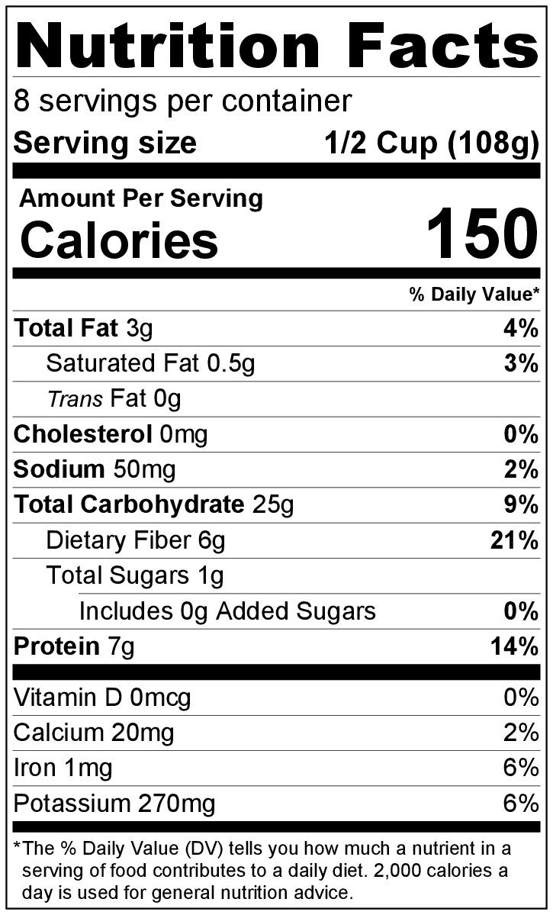
Cooking Time: 10 minutes

Ingredients
½ cup broth (chicken or vegetable)
½ cup uncooked couscous
1 ½ tablespoons vegetable oil
1 teaspoon apple cider vinegar
½ teaspoon ground cumin
1 tablespoon fresh lime juice (optional)
1 (15 ounce) can black beans, drained and rinsed
½ medium onion, minced
½ red or green pepper, minced
½ cup frozen thawed or canned whole kernel corn
Salt and black pepper to taste
2 tablespoons chopped fresh cilantro (optional)

Directions
- Before starting to prepare the recipe:
  - Wash red or green pepper and cilantro (if using).
  - Wash and juice the lime into a small bowl (if using).
  - Drain and rinse the black beans and corn (if using canned corn).
  - Collect, mince, and measure all ingredients.
- Bring broth to a boil in a small pot, and stir in the couscous.
- Cover the pot, and remove it from the heat. Let stand for 5 minutes.
- In a large bowl, whisk together oil, vinegar, cumin, and lime juice (if using).
- Add beans, onion, green pepper, and corn to the vinegar and oil mixture, and toss.
- Fluff the couscous well with a fork, breaking up any chunks. Add to beans and vegetables, and mix well.
- Taste. Add salt and black pepper if desired.
- Add cilantro (if using) and serve.
- Refrigerate leftovers within 2 hours. Eat within 3 to 5 days.

