Mexican Pinwheels

Makes: 6 servings (5 pinwheels per serving)
Preparation Time: 10 minutes

Ingredients
3 ½ tablespoons (2 ounces) cream cheese, softened
2 tablespoons canned corn, drained
2 tablespoons canned, chopped green chiles, drained
2 teaspoons minced onion
2 tablespoons salsa
3 (10 inch) white or whole wheat flour tortillas

Directions
- Drain the corn and green chiles.
- Collect, chop, and measure all ingredients before starting to prepare the recipe.
- Mix cream cheese, corn, green chiles, onion, and salsa in a bowl.
- Spread mixture on tortillas, roll up tightly, and wrap in plastic wrap.
- Cut in 1 inch slices, and serve immediately, or store in the refrigerator until ready to serve.
- Refrigerate leftovers within 2 hours. Eat within 3 to 5 days.

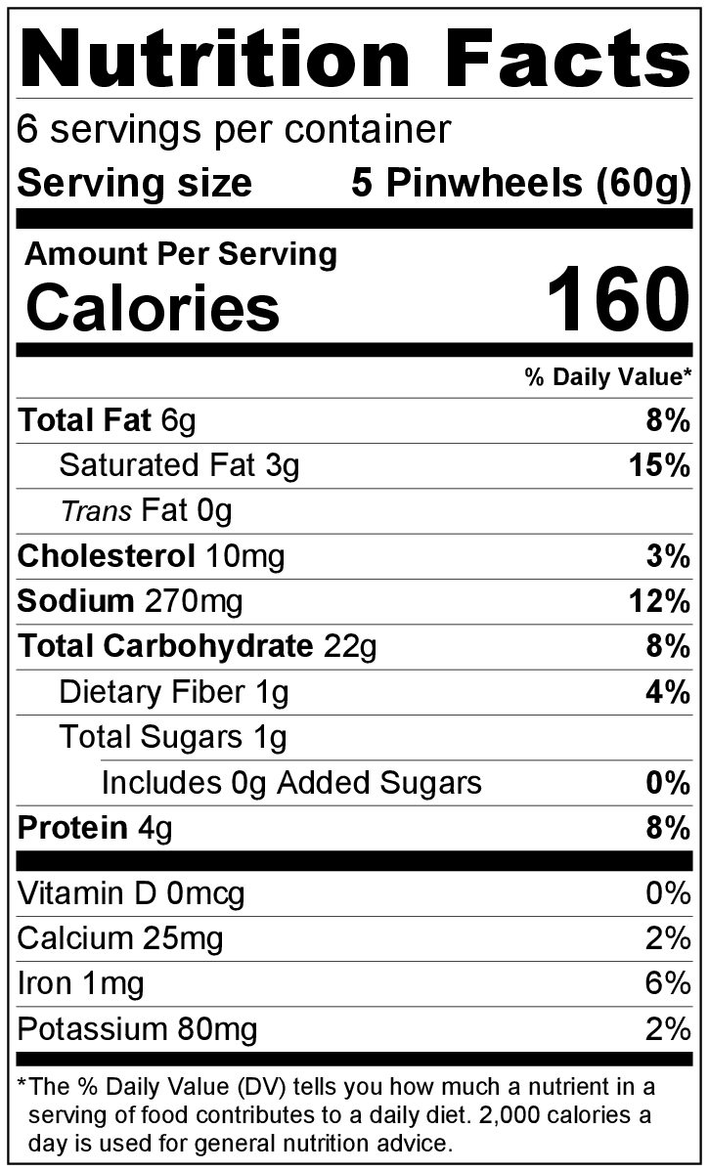
Be creative! Add washed, chopped fresh cilantro or spices like cumin and chili powder in step #3.
White Flour Tortillas

