Quick and Easy Pizza

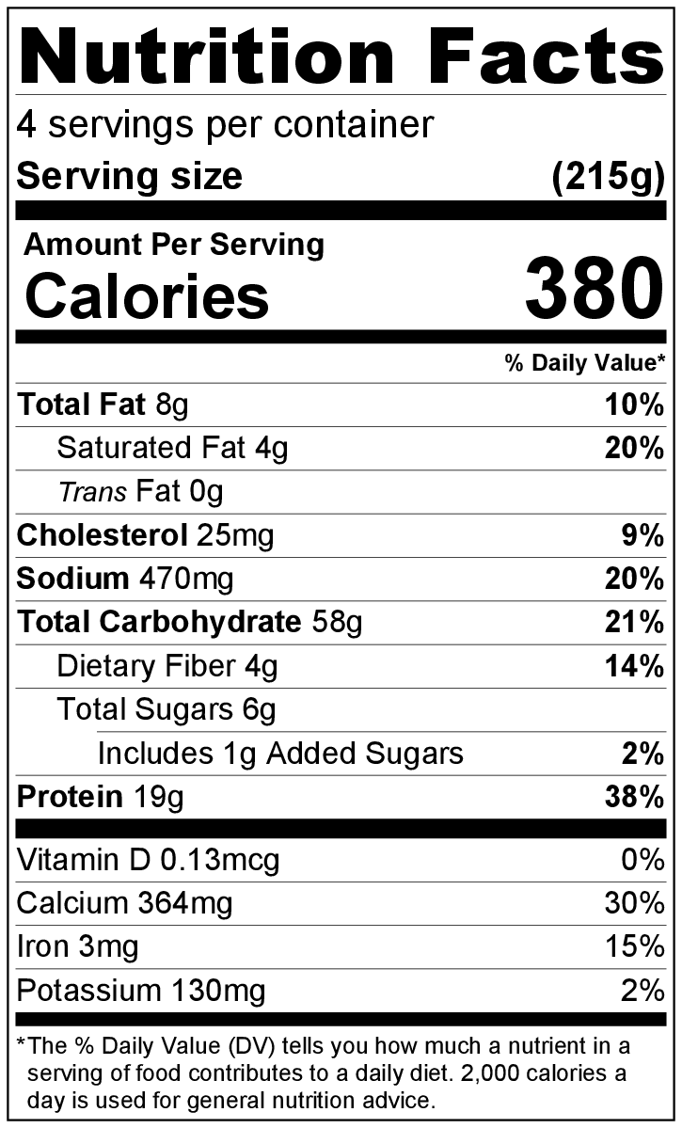
Makes: 12 inch x 16 inch pizza (4 servings)
Preparation Time: 30 minutes
Cooking Time: 19-26 minutes

Ingredients
2 cups all-purpose flour, divided in half*
1 packet rapid rise instant yeast (2 ¼ teaspoons)
1 teaspoon sugar
¾ cup warm water (110°F to 115°F)
Nonstick cooking spray
½ teaspoon of Italian seasoning
1 cup Easy Marinara Sauce from the Eating Smart • Being Active Let’s Cook! cookbook
6 ounces mozzarella cheese, shredded (1 ½ cups shredded)
Toppings of your choice

Directions
- Preheat oven to 375°F.
- Collect, shred, and measure all ingredients before starting to prepare the recipe.
- In a medium bowl, mix 1 cup flour, yeast, sugar, and water with a spoon.
- Gradually stir in the other cup of flour until the mixture forms a ball**. Be careful not to overmix the dough.
- Dust a cutting board or clean countertop surface with flour. Put the ball of dough on the surface, then use your clean hands to knead the dough for about 5 minutes.
- Spray a bowl with nonstick cooking spray. Put the dough in the bowl, and cover it with a clean dishtowel. Put the bowl on the oven while it is preheating (but not on a burner that is turned on), and let it sit for 15 minutes (preheating the oven will cause the stovetop to be slightly warm and will help the dough rise).
- Spray a 10 inch x 15 inch baking sheet with nonstick cooking spray. Spread the dough into an even ⅛ inch layer on the baking sheet. For a thicker crust, use a smaller baking sheet.
- Sprinkle the Italian seasoning evenly on the dough.
- Bake the pizza dough without any toppings in the preheated oven for 3 minutes**.
- Add a thin layer of the Easy Marinara Sauce from the Eating Smart • Being Active Let’s Cook! cookbook, leaving a ½ inch crust on all edges.
- Add the shredded cheese and pizza toppings. Be careful not to put too many toppings on the pizza, or it will be soggy.
- Bake for approximately 16 to 20 minutes until the crust is brown and the cheese melts and is slightly browned in spots.
- Refrigerate leftovers within 2 hours. Eat within 3 to 5 days.

*Make it whole grain! For added fiber, make 1 of the cups whole wheat flour.

**At elevations of 3,000 feet and above: Use ¼ to a ½ cup less flour in step #4. Add enough flour so that the mixture forms a ball. Small amounts of flour (~1 teaspoon at a time) may need to be added during the kneading process. Add just enough flour so that the dough is not sticky, but not so much that the dough becomes tough. In step #9, bake the pizza dough without any toppings for an additional 3 minutes (6 minutes total).

