Roasted Vegetables
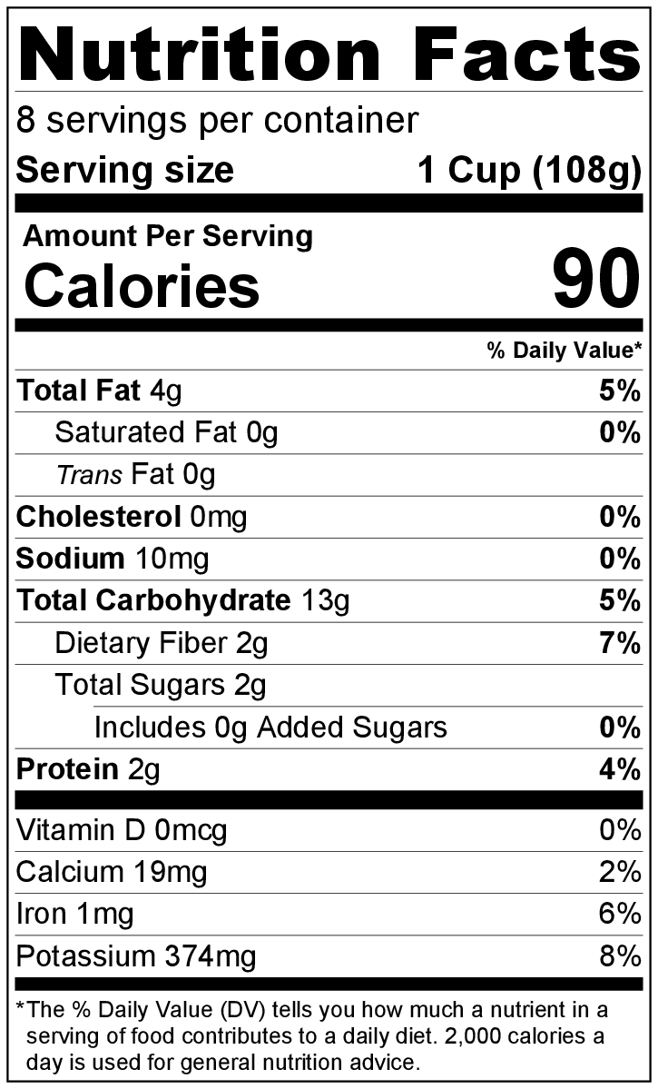
Makes: 8 servings (1 cup per serving)
Preparation Time: 10 minutes
Cooking Time: 15 to 30 minutes

Ingredients
Vegetables of your choice (see chart below)
Vegetable oil (1 teaspoon per 2 cups of vegetables)
Salt and black pepper

Directions
- Preheat oven to 425°F.
- Wash all vegetables.
- Collect all ingredients before starting to prepare the recipe.
- Cut and separate the vegetables of your choice by roasting time into different bowls (see chart below).
- Add vegetable oil, salt, and pepper to the vegetables in both bowls. Toss to coat all vegetables evenly.
yellow squash, zucchini, asparagus, Brussel sprouts, carrots, potatoes
- Arrange vegetables from each bowl in a single layer on 2 different baking sheets, separating by roasting time (see chart below).
- Roast in the oven until softened and slightly brown according to roasting time (see chart below).
- Remove from oven, and allow to cool slightly before serving.
- Refrigerate leftovers within 2 hours. Eat within 3 to 5 days.
Vegetables | Roasting time
Yellow Squash, cut into 1 inch pieces  Zucchini, cut into 1 inch pieces  Asparagus, ends trimmed | 15 minutes
Brussel sprouts, ends trimmed and cut in half  Carrots, peeled, ends trimmed, and cut into 1 inch pieces  Potatoes, cut into 1 inch pieces | 30 minutes

