Skillet Mac and Cheese

Makes: 12 servings (½ cup per serving)
Preparation Time: 5 minutes
Cooking Time: 25 minutes

Ingredients
3 tablespoons butter
½ large onion, chopped
3 cups finely chopped fresh spinach or ¾ cup frozen chopped spinach (thawed and squeezed dry)
2 tablespoons all-purpose flour
3 ½ cups milk*
¾ cup water*
2 ½ cups uncooked elbow macaroni
8 ounces cheddar cheese, shredded (2 cups shredded)
Directions
- Wash the spinach (if using fresh spinach).
- Collect, chop, shred, and measure all ingredients before starting to prepare the recipe.
- Melt the butter in a large skillet over medium heat.
- Add the onion, and cook for another 2 minutes. Add the spinach, and cook for 2 minutes or until wilted.
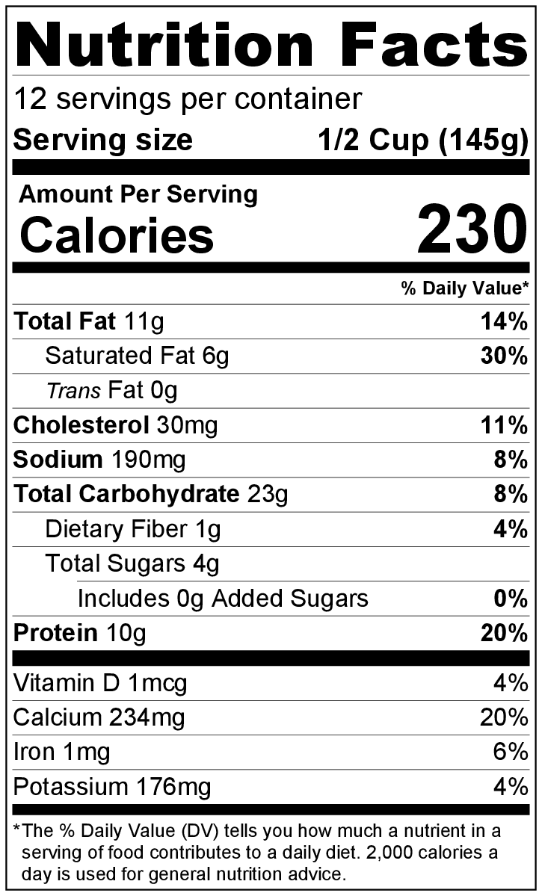
- Add the flour, and cook for 1 minute, stirring constantly.
- Add the milk and water, stirring frequently. Bring the mixture to a low boil and then reduce heat.
- Add the uncooked macaroni. If the macaroni is not completely covered by liquid, add additional water to bring the level of the water just over the macaroni.
- Cover and simmer, over low heat, for 8 to 9 minutes, stirring occasionally. The mixture will thicken as it simmers.
- Once the macaroni is tender, remove from the heat.
- Add the shredded cheese, and stir to combine. Cover and let sit for 5 minutes before serving.
- Refrigerate leftovers within 2 hours. Eat within 3 to 5 days.

*At elevations of 3,000 feet and above: use 3 cups of milk and ½ cup of water instead of the amounts listed above.

Be creative! Try using whole wheat pasta. Substitute other veggies like peas or carrots for spinach.

