Stir-Fried Vegetables with Beef, Chicken, or Tofu

Makes: 6 servings (1 cup stir fry and 1 cup rice per serving)
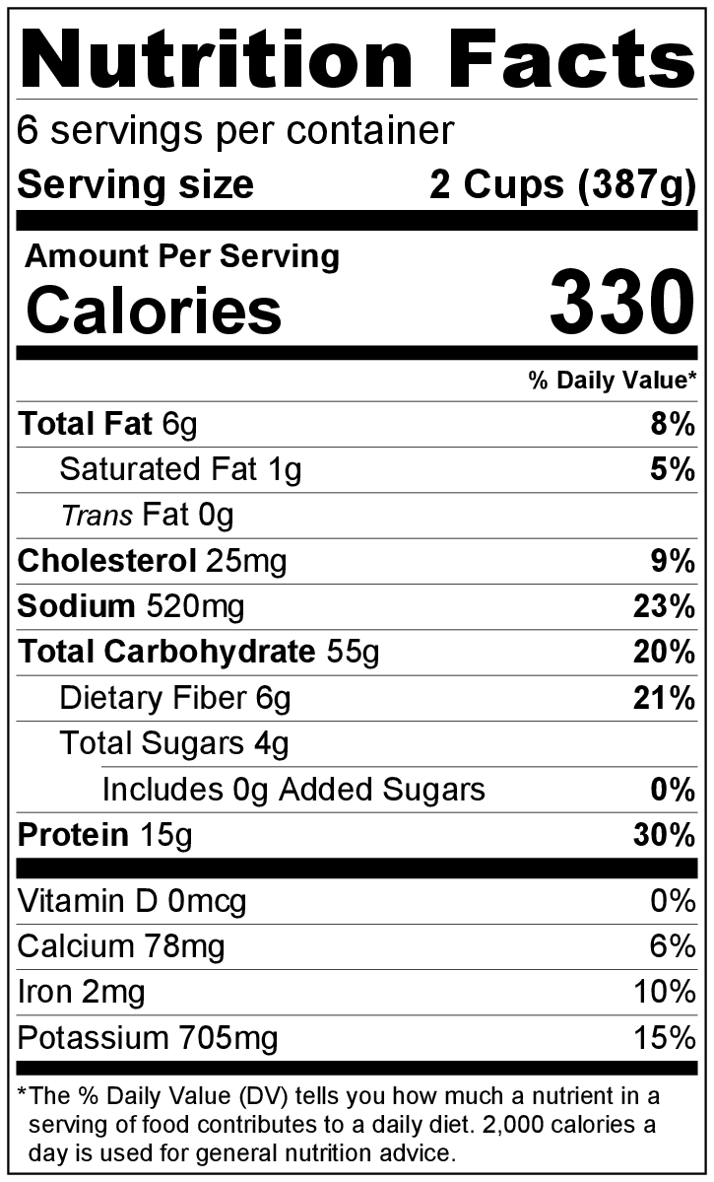
Preparation Time: 15 minutes
with Chicken
Cooking Time: 12 to 18 minutes

Ingredients
6 cups cooked brown rice
1 cup broth (chicken or vegetable)
2 tablespoons soy sauce
1 tablespoon cornstarch
1 teaspoon garlic powder
Pinch of black pepper
3 teaspoons vegetable oil
5 cups sliced fresh vegetables (such as celery, broccoli, zucchini, onions, green beans, carrots, peppers)
2 cups uncooked chopped chicken or beef or 4 ounces firm tofu in bite size pieces

Directions
- Cook rice according to package directions. The package will indicate how much uncooked rice is needed to make 6 cups of cooked rice
- Wash all vegetables.
- Collect, slice, and measure all ingredients before starting to prepare the recipe.
- Mix together broth, soy sauce, cornstarch, garlic powder, and pepper in small bowl. Set aside.
- Heat 1 ½ teaspoons of oil in a large skillet over medium high heat, and add vegetables. Cook for 5 minutes, stirring often.
- Remove vegetables from skillet.
- Heat remaining 1 ½ teaspoons oil over high heat in the skillet, then add beef, chicken or tofu to the skillet. Stir until thoroughly cooked.
- Lower heat to medium low. Return vegetables to skillet.
- Pour broth mix over vegetables and meat/tofu. Cook for 2 minutes, stirring constantly, or until liquid thickens.
- Serve immediately over heated, cooked rice.
- Refrigerate leftovers within 2 hours. Eat within 3 to 5 days.

Be creative! Add frozen veggies in step #4 or any leftover cooked veggies or cooked meat before step #7.

