Downloading the Eating Smart • Being Active
Mobile App for iPhone

- Go to the APP STORE
  - Tap the SEARCH icon
  - Type in EATING SMART BEING ACTIVE
  - Tap GET, and the app will download
  - Tap OPEN

d.
c.
b.
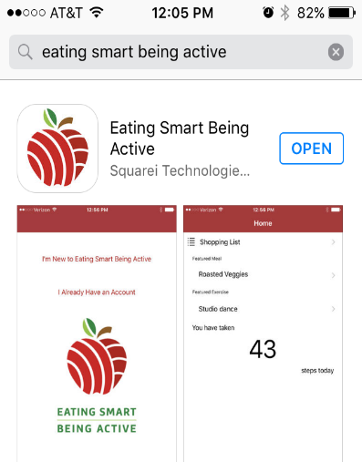
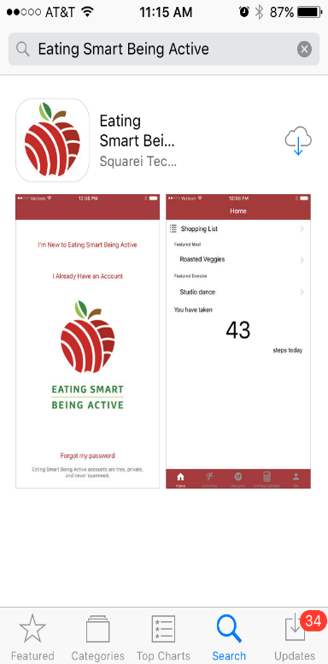
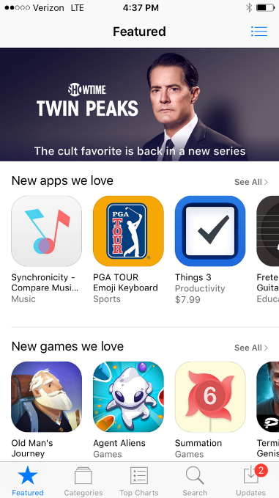

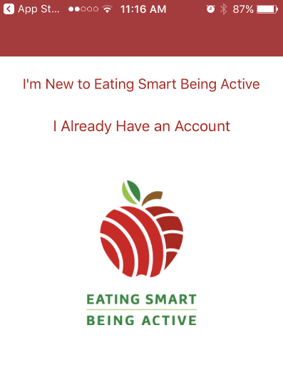
- CREATE AN ACCOUNT once the App is downloaded.
Tap I’M NEW TO EATING SMART BEING ACTIVE

- Choose a language ENGLISH or SPANISH
- Either enable or disable the STEP TRACKER
  - Some phones won’t be able to track your steps. With newer smartphones, you can track your steps just by carrying the phone in your pocket. This feature is built into the Apple Health app on iPhones.
  - If you enable the Step Tracker, the app will use the steps recorded by your phone’s Step Tracker and display them each time you open the app.
- Fill in the next set of boxes for EMAIL ADDRESS, PASSWORD, and CONFIRM PASSWORD.
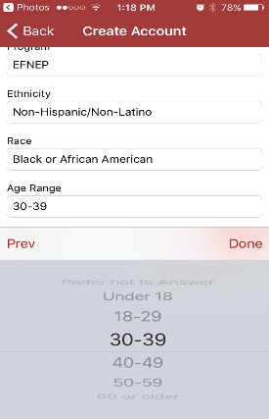
- Use the drop down menus to select your STATE (a), the PROGRAM (b), your ETHNICITY (c), RACE (d), and AGE RANGE (e).
e.
e.
d.
d.
c.
c.
b.
b.
a.
a.
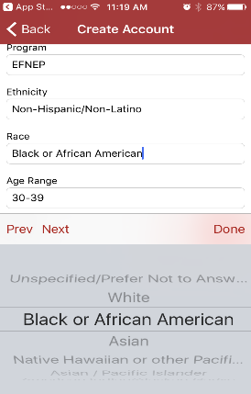
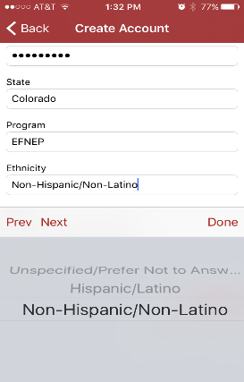
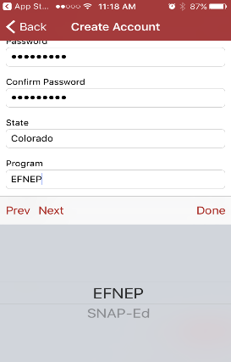
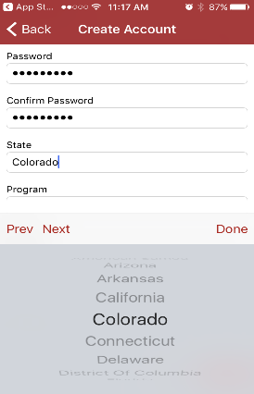
- Choose your GENDER (f) – male or female
- Tap CREATE ACCOUNT (g)
f.

g.

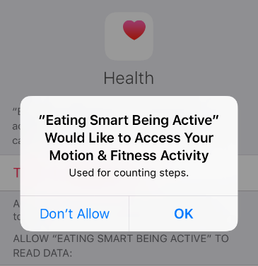
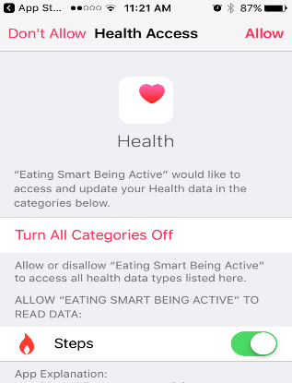
Note: If you are using an iPhone with a built in step tracker, a message will pop up asking you to allow the app to access this information. Tap OK, then tap the STEPS toggle button so it turns green, then tap ALLOW in the upper right hand corner of the screen.

You did it! The Eating Smart • Being Active mobile app should now be downloaded to your phone.

