Cabbage Stir-Fry

Makes: 6 servings (1 cup per serving)
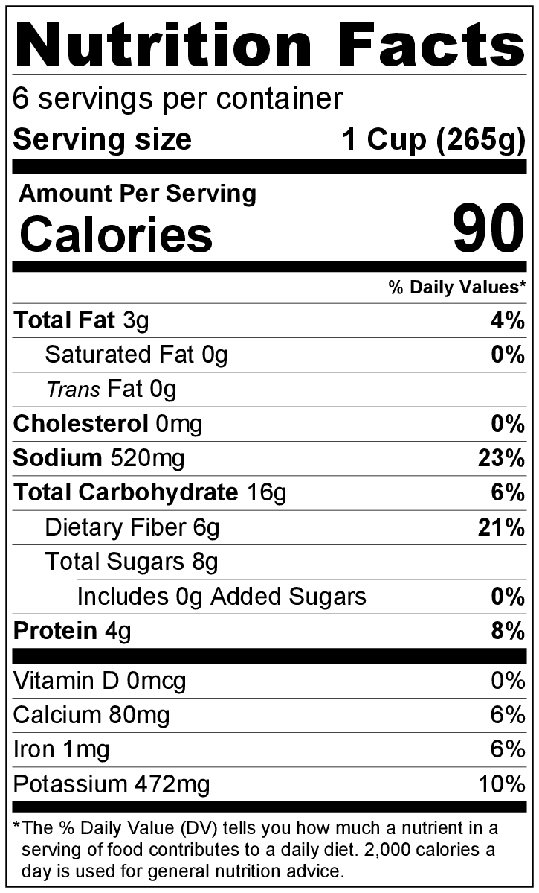
Preparation Time: 12 minutes
Cooking Time: 10 minutes

Ingredients
1 tablespoon vegetable oil
1 small onion, chopped
2 green peppers, chopped
1 medium head of cabbage, chopped
½ teaspoon garlic powder
3 tablespoons soy sauce

Directions
- Wash all vegetables.
- Collect, chop, and measure all ingredients before starting to prepare the recipe.
- Heat oil in a skillet.
- Add onion, green pepper, cabbage, and garlic powder to skillet, and cook over medium heat until vegetables are tender.
- Add soy sauce, and stir to combine.
- Serve hot.
- Refrigerate leftovers within 2 hours. Eat within 3 to 5 days.

Be creative!
- Turn into a main dish by serving with brown rice or barley.
- Try adding other vegetables or cooked meat you have on hand.
- Use red pepper instead of green pepper.

