Sweet Potato Fries

Makes: 6 servings (½ cup per serving)
Preparation Time: 10 minutes
Cooking Time: 25 minutes

Ingredients
3 large sweet potatoes, peeled and cut into 2 inch long and ¼ inch thick pieces*
1 tablespoon vegetable oil
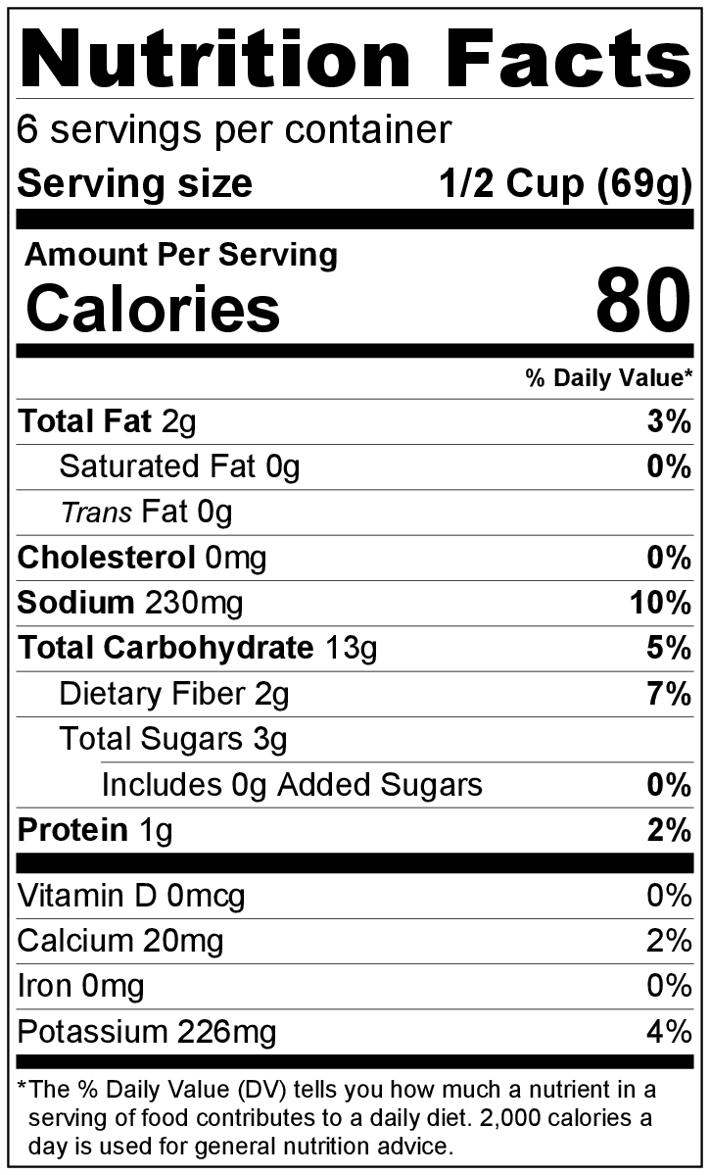
½ teaspoon paprika
½ teaspoon salt
¼ teaspoon black pepper
½ teaspoon garlic powder

Directions
- Preheat the oven to 425°F.
- Wash and peel the sweet potatoes.
- Collect, cut, and measure all ingredients before starting to prepare the recipe.
- In a large bowl, toss the sweet potatoes with the oil to coat.
- Add the paprika, salt, pepper, and garlic powder, and mix to coat. Spread sweet potato fries in a single layer on a baking sheet, making sure they do not overlap.
- Bake about 20 minutes, turning halfway through, until they are tender and golden brown.
- Turn the oven to broil, and allow to cook for another 3 to 5 minutes until potatoes reach desired crispness.
- Allow to cool for 5 minutes before serving.
- Refrigerate leftovers within 2 hours.
- Reheat leftovers in a single layer at 350°F until hot. Eat within 3 to 5 days.

* Be sure the sweet potato pieces are about the same size (so they cook evenly) and very thin (so they get crispy when cooking).

