Baked Chicken Nuggets

Makes: 4 servings
Preparation Time: 10 minutes
Cooking Time: 10 minutes

Ingredients
Nonstick cooking spray
1 egg
½ cup milk
¼ teaspoon salt
4 cups cornflakes
2 boneless, skinless, raw chicken breasts, cut into small pieces

Directions
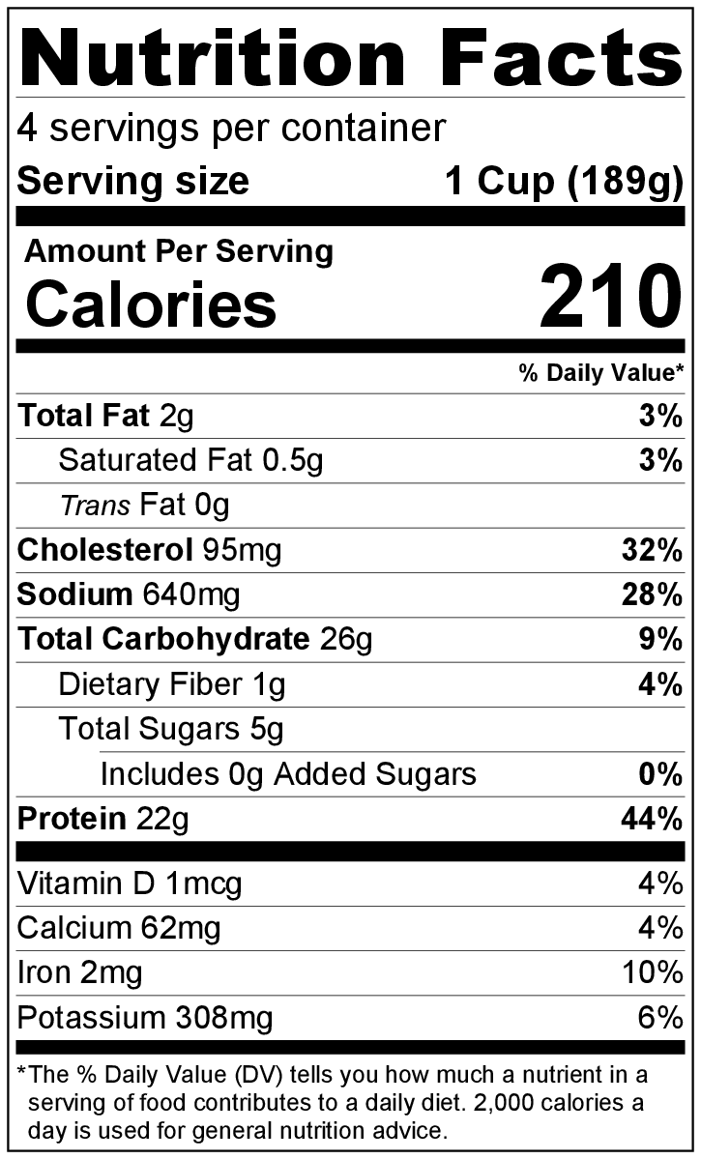
- Preheat oven to 375°F.
- Collect, cut, and measure all ingredients before starting to prepare the recipe.
- Spray baking sheet with cooking spray.
- Mix egg, milk, and salt with fork in a small bowl.
- Place cornflakes in a sealable plastic bag, seal, and crush into tiny bits.
- Dip chicken pieces in the beaten egg and milk mixture, then drop the chicken pieces into the plastic bag of cornflakes and seal. Shake to coat evenly.
- Place nuggets in a single layer on the baking sheet.
- Bake 10 minutes. Check for doneness, and continue baking if needed. Nuggets are done when they are golden brown and have no pink on the inside when cut open.
- Serve hot with ketchup or barbecue sauce.
- Refrigerate leftovers within 2 hours. Eat within 3 to 5 days.

