Chili Tomato Beefy Macaroni
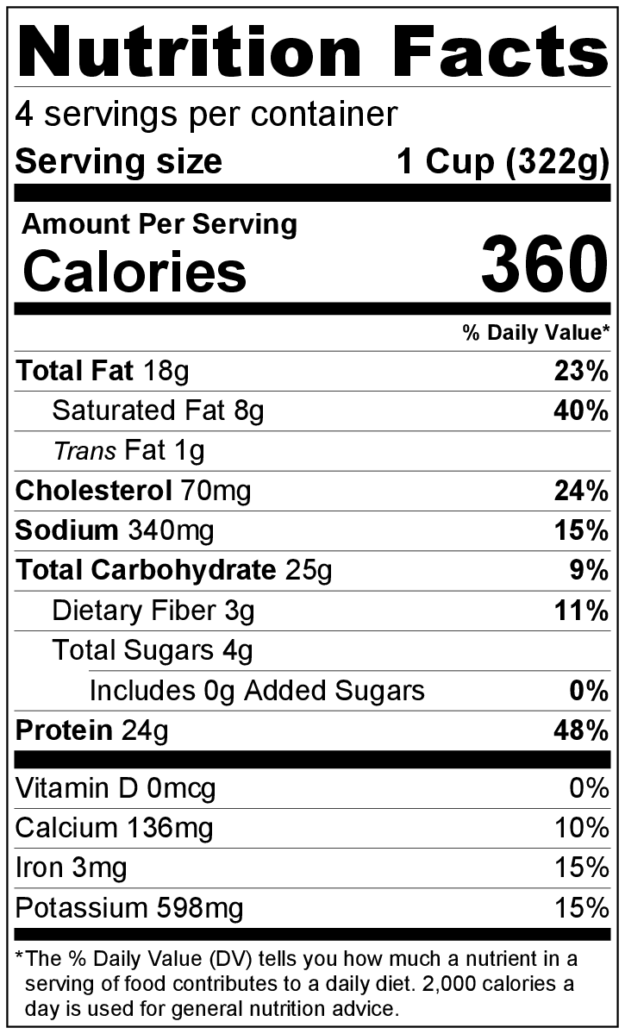
Makes: 4 servings (1 cup per serving)
Preparation Time: 10 minutes
Cooking Time: 25 to 30 minutes

Ingredients
¾ pound ground beef
1 ½ cups water
1 cup uncooked macaroni
1 (15 ounce) can diced tomatoes, not drained
2 teaspoons chili powder (optional)
½ cup Eating Smart Seasoning Mix from the Eating Smart • Being Active Let’s Cook! cookbook*
Salt, to taste
2 ounces cheddar cheese, shredded (½ cup shredded)

Directions
- Collect, shred, and measure all ingredients before starting to prepare the recipe.
- Brown ground beef over medium heat in a large skillet. Remove the skillet from the heat. Remove excess fat by pushing the beef to one side, then tilting the skillet in the opposite direction so the liquid fat pools away from the beef. Use a large spoon to remove the liquid fat from the pan. Discard the fat in the trash can.
- Put the skillet back on the heat. Add water, macaroni, tomatoes, chili powder (if using), and seasoning mix to the skillet, and combine with the beef.
- Bring to a boil, then reduce heat to low, cover, and simmer for approximately 20 minutes or until macaroni is tender.
- Taste, and add a small amount of salt if desired.
- Top with shredded cheddar cheese. Put the lid back on for 1 minute until the cheese is melted.
- Refrigerate leftovers within 2 hours. Eat within 3 to 5 days.

* This Eating Smart Seasoning Mix is used in two recipes in the Eating Smart • Being Active Let’s Cook! cookbook. Store any leftover mix in a sealable plastic bag or container in a cabinet with other spices until ready to use.

Be creative! Try using whole grain pasta. Add chopped vegetables such as green pepper or onion in step #3.

