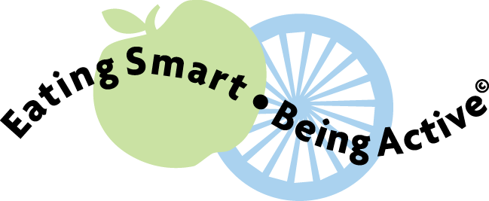  Feeding Your New Baby |  | Feeding Your New Baby

Feeding Your New Baby |  | Feeding Your New Baby
Feeding Your New Baby |  | Feeding Your New Baby

