Downloading the Eating Smart • Being Active
Mobile App for Android Phones
- Go to the PLAY STORE
  - Tap in the SEARCH box at the top of the screen
  - Type in EATING SMART BEING ACTIVE
  - Tap INSTALL, and the app will download
  - The phone will then say “Eating Smart • Being Active Needs Access to Identity.” Tap ACCEPT.
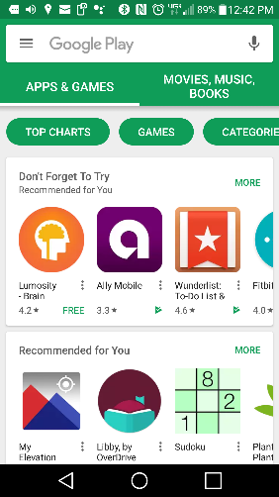
  - Tap OPEN
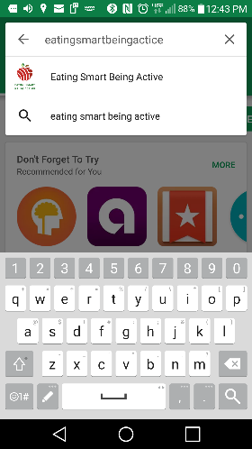
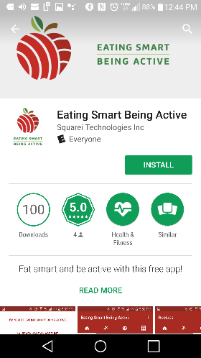

c.
b.

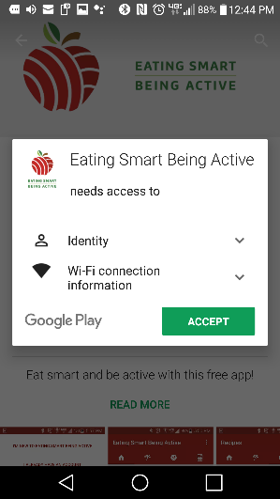
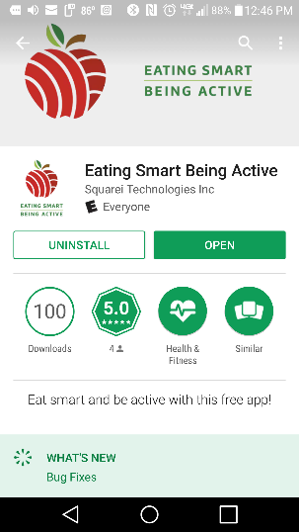
d.
e.

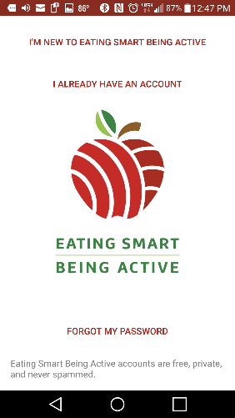
- CREATE AN ACCOUNT once the App is downloaded.
Tap I’M NEW TO EATING SMART BEING ACTIVE

- Choose a language ENGLISH or SPANISH

- Either enable or disable the STEP TRACKER
  - Some phones won’t be able to track your steps. With newer smartphones, you can track your steps just by carrying the phone in your pocket.
  - If you enable the Step Tracker, the app will use the steps recorded by your phone’s Step Tracker and display them each time you open the app.

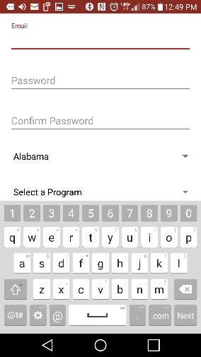
- Fill in the next set of boxes:
a.
  - EMAIL ADDRESS

  - PASSWORD
  - then CONFIRM PASSWORD.

e.
d.
c.
- Use the drop down menus to select your STATE (a), your PROGRAM (b), your ETHNICITY (c), and your RACE (d).
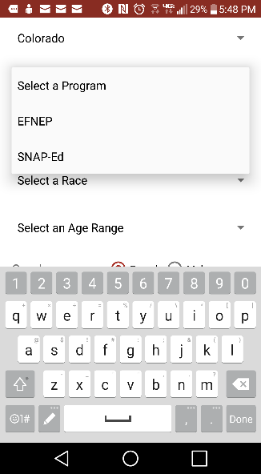
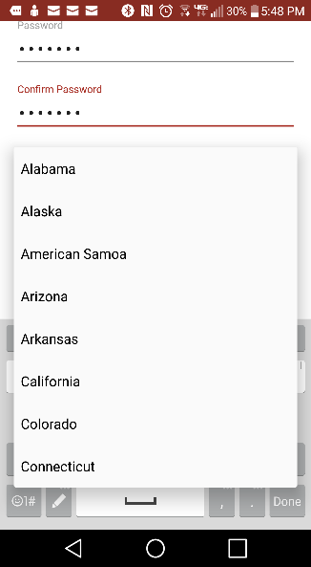
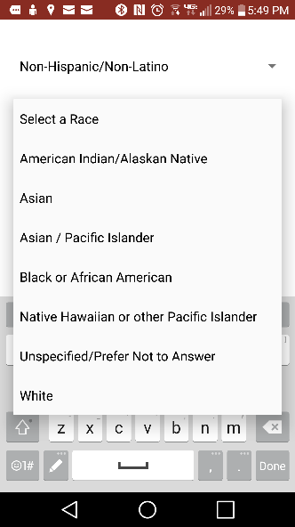
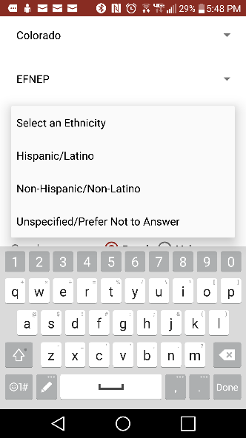
b.
a.
c.
d.

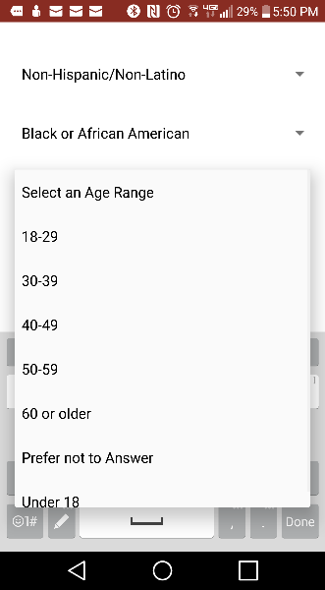
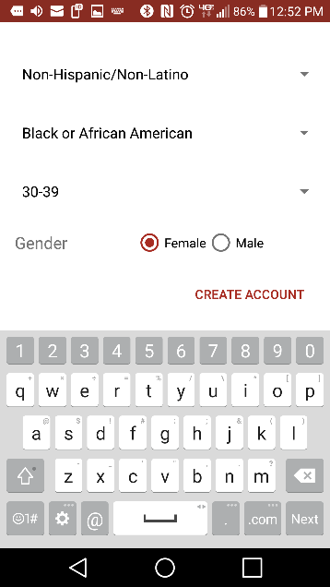
- Select your AGE RANGE (e).

- Choose your GENDER (f) – male or female.
f.
e.
- Tap CREATE ACCOUNT (g)
f.

g.

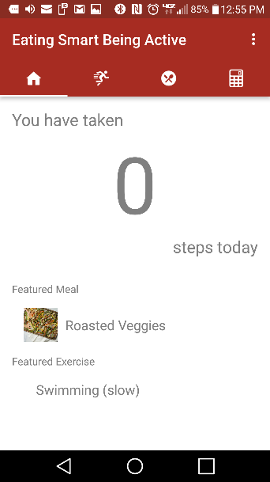
*Wording may vary depending on the version of Android phone you have.
You did it! The Eating Smart • Being Active mobile app should now be downloaded to your phone.

