Simple Fish Tacos

Makes: 6 servings (2 tacos per serving)
Preparation Time: 15 minutes
Cooking Time: 4 to 5 minutes
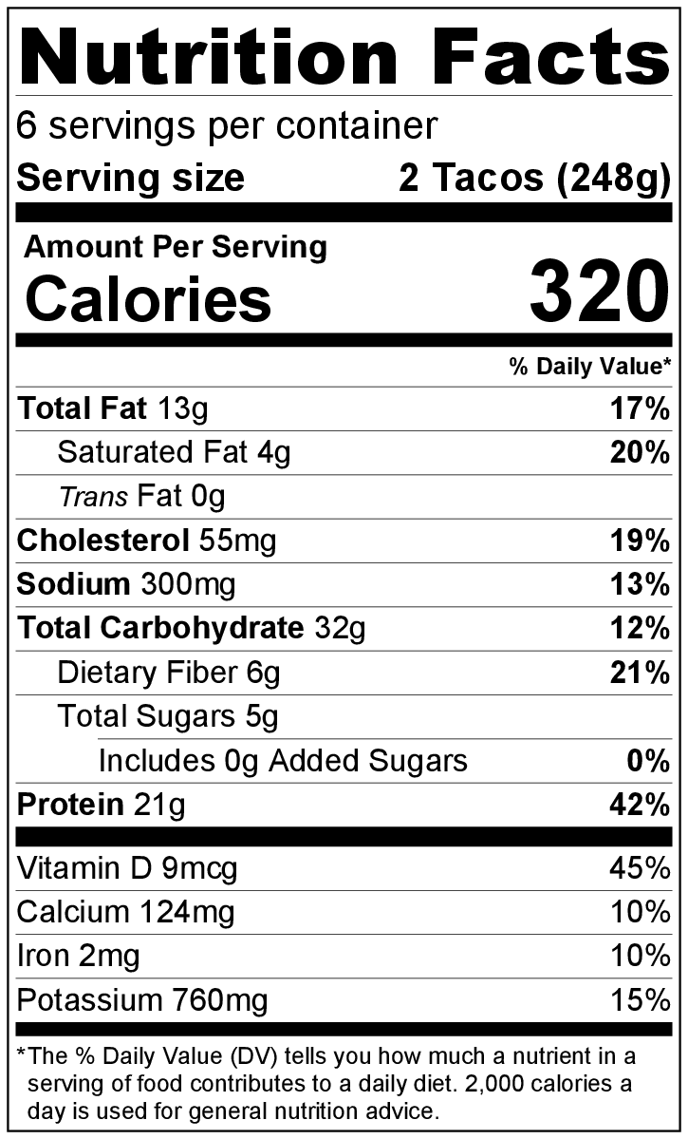
Ingredients
1 tablespoon vegetable oil
2 tablespoons lemon juice
1 packet (1.25 ounces) taco seasoning
¾ cup sour cream
½ cup chopped, fresh cilantro (optional)
Nonstick cooking spray
12 (6 inch) corn tortillas
1 pound tilapia fillets (4 fillets) frozen, thawed
2 cups shredded cabbage
2 large tomatoes, diced
Lime wedges (optional)

Directions
- Wash all produce.
- Collect, cut, and measure all ingredients before starting to prepare the recipe.
- In a small bowl, mix oil, lemon juice, and 1 ½ teaspoons of taco seasoning. Set aside.
- In a second small bowl, combine sour cream, cilantro (if using), and 2 tablespoons of taco seasoning mix. Set aside.
- Spray a large skillet with cooking spray. Add tortillas to the skillet one at a time. Heat briefly on both sides over medium heat until warm and soft. Wrap in 2 layers of foil, put on a plate, and cover with another plate to keep warm.
- Spray the skillet with cooking spray again. Place fish fillets in the skillet. Cook over medium heat for 1 ½ minutes until golden brown, flip, and cook another 1 ½ minutes until golden brown on the other side.
- Pour the lemon juice mixture over the fish. Cook for another 1 to 2 minutes. When the fish flakes easily with a fork, it is done. Break the fish into bite-sized pieces.
- Fill tortillas with fish, and top with a bit of the sour cream mixture.
- Top with shredded cabbage, diced tomato, and a squeeze of fresh lime (if using).
- Refrigerate leftovers within 2 hours. Eat within 3 to 5 days.

