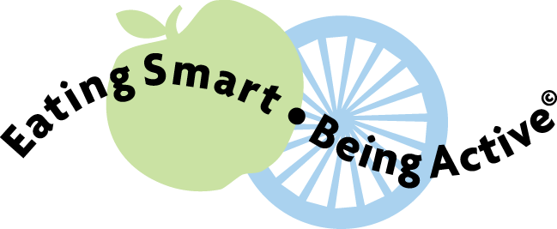  Eating Smart and Being Active During Pregnancy |  | Eating Smart and Being Active During Pregnancy

Eating Smart and Being Active During Pregnancy  Eating Smart and Being Active During Pregnancy |  | Eating Smart and Being Active During Pregnancy
Eating Smart and Being Active During Pregnancy |  | Eating Smart and Being Active During Pregnancy

