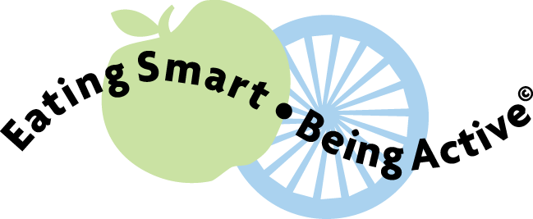  Feeding Your Baby Solid Foods |  | Feeding Your Baby Solid Foods

Feeding Your Baby Solid Foods |  | Feeding Your Baby Solid Foods
Feeding Your Baby Solid Foods |  | Feeding Your Baby Solid Foods

