Banana Swirl

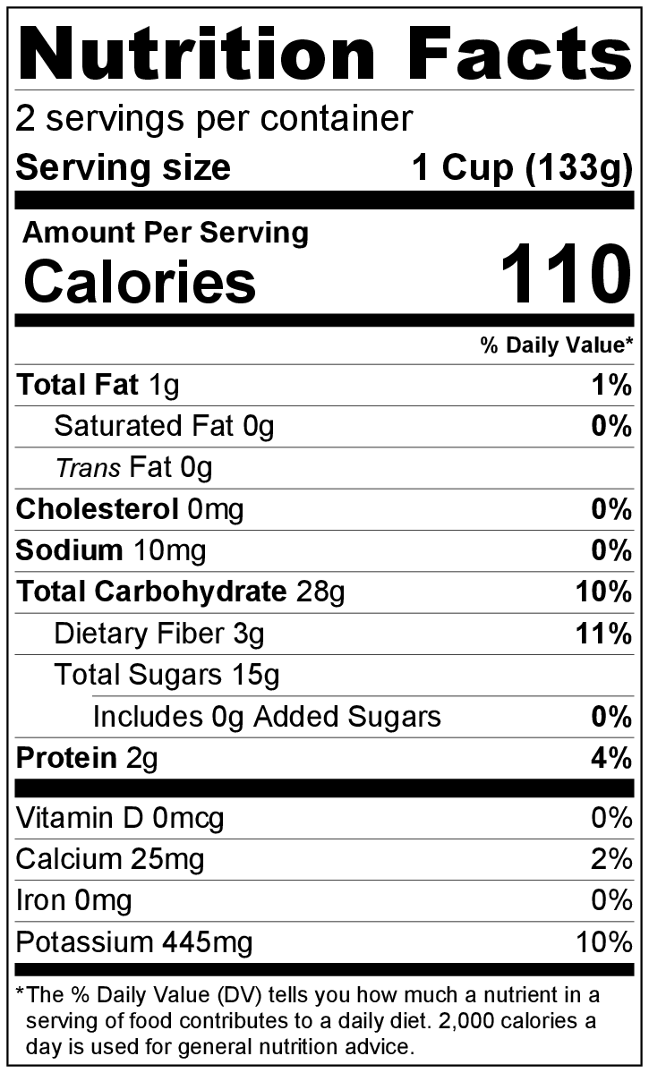
Makes: 2 servings (1 cup per serving)
Preparation Time: 5 minutes
Freezing Time: 2 to 3 hours

Ingredients
2 bananas (frozen)
2 tablespoons milk
Toppings of your choice (suggestions: nuts, chocolate chips, sliced fruit)

Directions
- Peel bananas, and cut into chunks.
- Spread individual pieces of banana in a single layer on a baking sheet; place baking sheet in the freezer for at least 2 hours.
- Remove bananas from freezer, and put in a blender. Add milk, and blend until smooth.
- Add toppings of your choice (if using).
- Serve immediately.
- Freeze any leftovers in a freezer-safe container.

Be creative! Add 2 teaspoons of unsweetened cocoa powder to make a chocolate banana swirl.

