Cowboy Caviar

Makes: 16 servings (½ cup per serving)
Preparation Time: 10 minutes

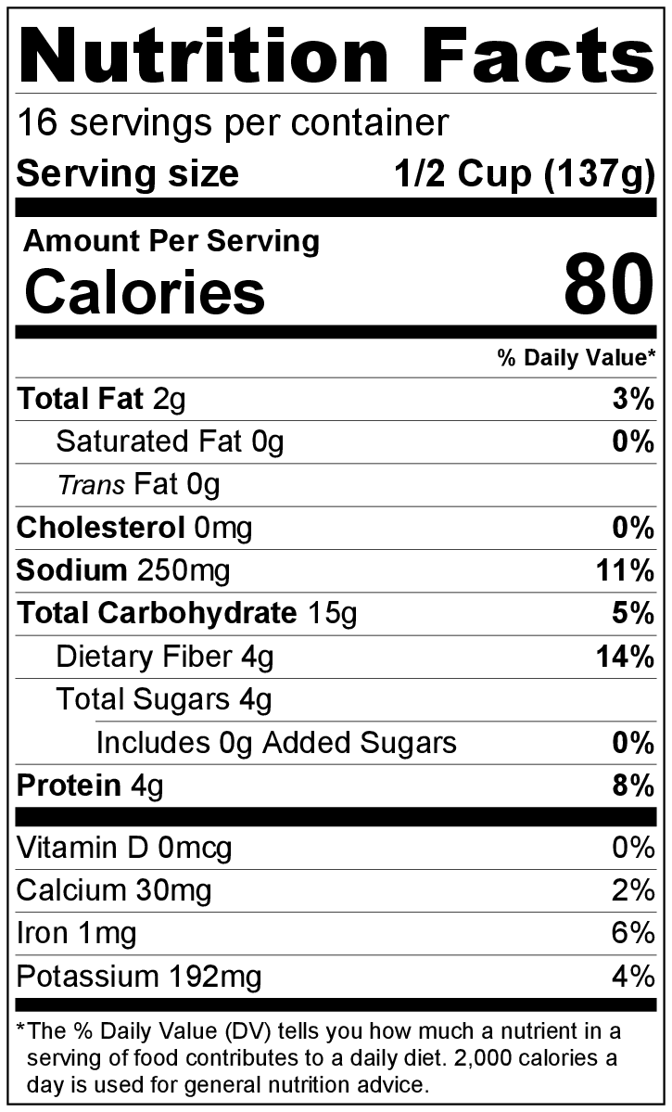
Ingredients
1 (15 ounce) can kidney beans, drained and rinsed
1 (15 ounce) can black beans, drained and rinsed
1 (15 ounce) can corn, drained and rinsed
1 (4 ounce) can chopped green chiles, not drained
1 (15 ounce) can crushed or diced tomatoes, not drained
½ medium onion, minced
3 limes, juiced (optional)
1 tablespoon vegetable oil
Salt to taste
Black pepper to taste
Hot sauce (optional)

Directions
- Before starting to prepare the recipe:
  - Open, drain, and rinse beans and corn.
  - Open chiles and tomatoes, but do not drain.
Dip only
  - Mince and measure the remaining ingredients.
  - Wash and juice the limes into a small bowl (if using).
- Mix kidney beans, black beans, corn, chiles, tomatoes, and minced onion in a large bowl.
- Add lime juice (if using) and oil to the bean mixture, and stir gently to combine.
- Taste. Add a small amount of salt and black pepper if desired.
- Serve as a dip with Baked Tortilla Chips from the Eating Smart • Being Active Let’s Cook! cookbook and/or raw vegetables.
- Refrigerate leftovers within 2 hours. Eat within 3 to 5 days.

Be creative! Substitute any kind of beans you have. Make it spicier by adding chopped jalapenos or hot sauce.

