Cranberry Pecan Granola

Makes: 16 servings (⅓ cup per serving)
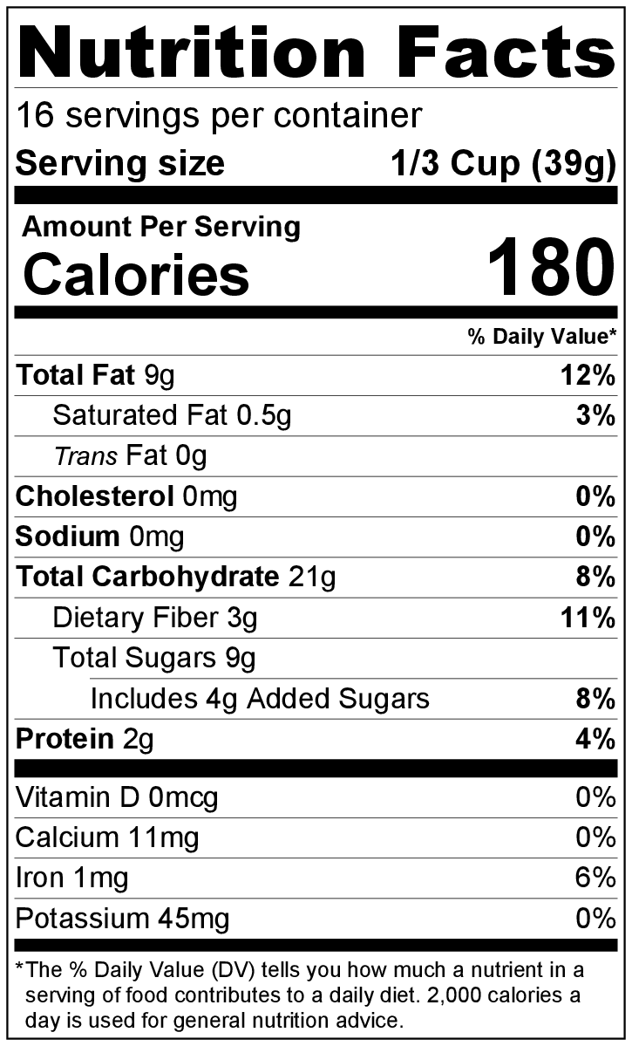
Preparation Time: 10 minutes
Cooking Time: 25 to 30 minutes

Ingredients
Nonstick cooking spray
3 cups rolled oats
1 cup chopped pecans
⅓ cup maple syrup (or honey or agave syrup)
¼ cup vegetable oil
1 tablespoon ground cinnamon
2 teaspoons vanilla extract
1 cup dried cranberries (optional)

Directions
- Preheat oven to 325°F.
- Collect, chop, and measure all ingredients before starting to prepare the recipe.
- Spray a large baking sheet with cooking spray, and set aside.
- Combine oats and pecans in a large bowl.
- In a small sauce pan, combine maple syrup, vegetable oil, and cinnamon. Cook over low heat, stirring frequently until mixture becomes thin. Remove from heat, and stir in vanilla.
- Pour warm mixture over oats and pecans, and stir to coat evenly.
- Spread mixture in an even layer on the baking sheet.
- Bake for 25 minutes.
- Remove from the oven, and allow to cool completely.
- Put the cooked granola in a large bowl, add the cranberries, and stir until the cranberries are evenly distributed.
- Store in an airtight container at room temperature for up to 7 days.

Be creative! Use walnuts or almonds instead of pecans, and/or use raisins instead of cranberries.

