Fruit Salad

Makes: 6 servings (½ cup per serving)
Preparation Time: 10 minutes
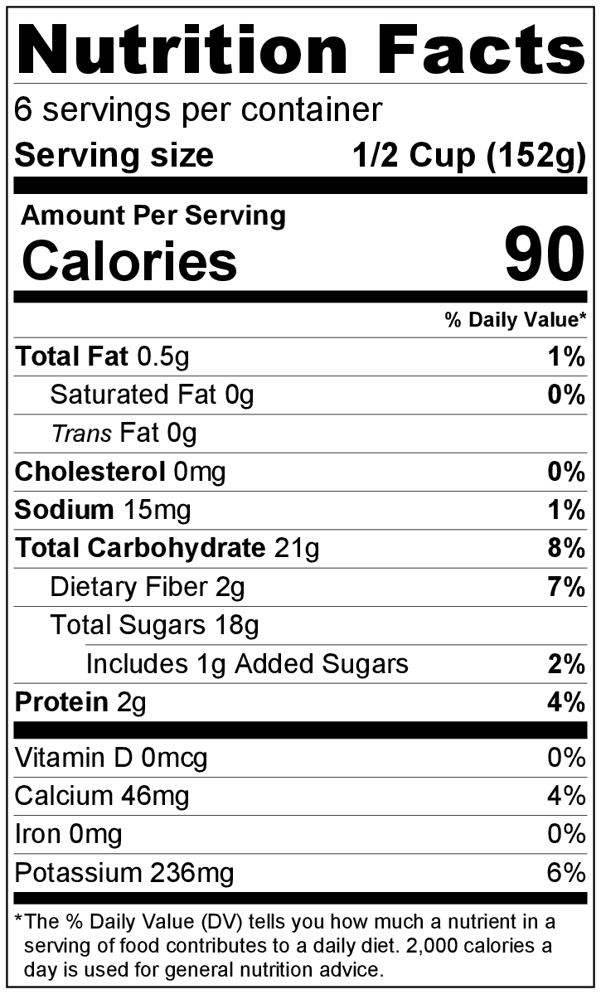
Ingredients
1 (8 ounce) can fruit cocktail packed in juice, drained
1 (8 ounce) can pineapple tidbits packed in juice, drained
1 apple, chopped
1 banana, sliced
½ cup (4 ounces) vanilla yogurt
Pinch of cinnamon or nutmeg

Directions
- Wash the apple.
- Collect, cut, and measure all ingredients before starting to prepare the recipe.
- Drain the juice from the cans of fruit cocktail and pineapple into a medium bowl. Toss the chopped apple and sliced banana in the fruit juice to prevent browning, then remove from the juice.*
- In a larger bowl, mix fruit cocktail, pineapple, apple, and banana.
- In a small bowl, mix the yogurt and cinnamon or nutmeg.
- Serve fruit salad in small bowls or cups. Top each serving with a spoonful of the yogurt mixture.
- Refrigerate leftovers within 2 hours. Eat within 3 to 5 days.

* When you drain the canned fruit, save the juice to drink or to add to a smoothie.

Be creative! Substitute any canned or fresh fruit (wash first).

