Vegetable Pinwheels

Makes: 6 servings (5 pinwheels per serving)
Preparation Time: 10 minutes

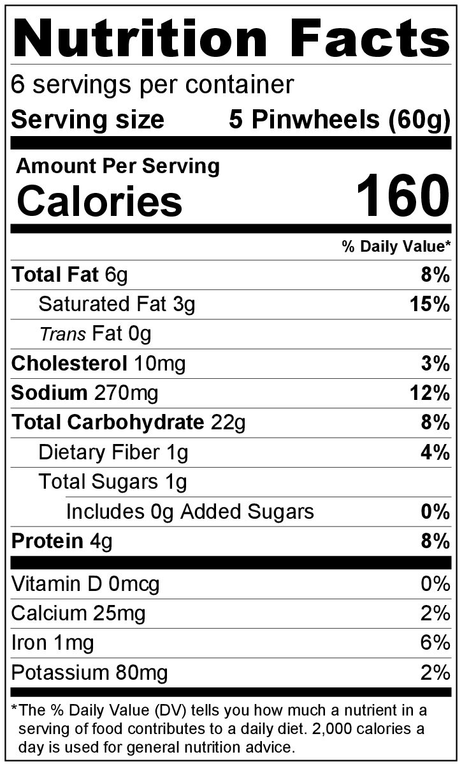
Ingredients
White Flour Tortillas
3 ½ tablespoons (2 ounces) cream cheese, softened
2 tablespoons canned, chopped green chiles, drained
2 tablespoons frozen or canned corn, drained
2 teaspoons minced onion
2 tablespoons salsa
3 (10 inch) white or whole wheat flour tortillas

Directions
- Collect, chop, and measure all ingredients before starting to prepare the recipe.
- Mix cream cheese, green chiles, corn, onion, and salsa in a bowl.
- Spread mixture on tortillas, roll up tightly, and wrap in plastic wrap.
- Cut in 1 inch slices, and serve immediately, or store in the refrigerator until ready to serve.
- Refrigerate leftovers within 2 hours. Eat within 3 to 5 days.

Be creative! Add washed, chopped fresh cilantro or spices like cumin and chili powder in step #2.

