Winter Italian Vegetables

Makes 6 servings (1 cup per serving)
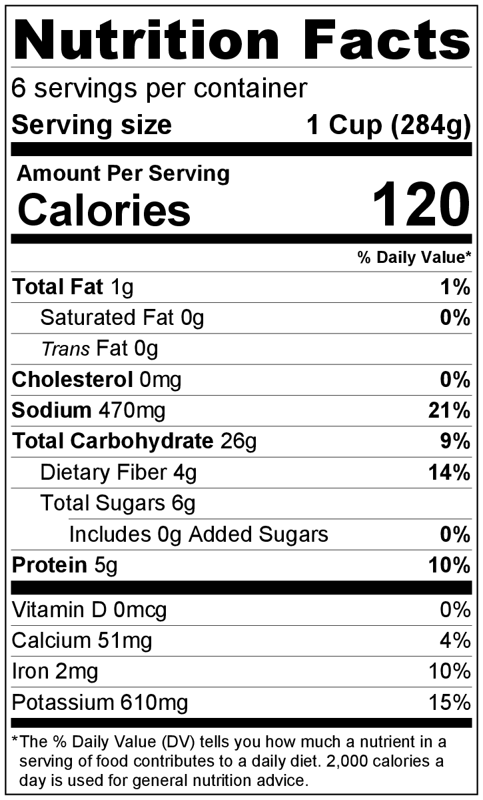
Preparation time: 15 minutes
Cooking time: 10 to 15 minutes

Ingredients
1 ½ cups uncooked spiral pasta
1 ½ cups water
1 (15 ounce) can tomato sauce
1 cup chopped broccoli
1 cup chopped cauliflower
2 medium zucchini, sliced
1 medium onion, diced
1 cup diced celery
2 teaspoons Italian seasoning
Salt and pepper to taste

Directions
- Wash all vegetables.
- Collect, cut, and measure all ingredients before starting to prepare the recipe.
- Put 1 ½ cup of water and 15 ounce can of tomato sauce in a large skillet and bring to a boil. Add dry pasta. Cover and cook pasta for 3 minutes.
- Add all the vegetables and Italian seasoning. Stir, reduce heat to medium low, cover, and simmer for about 8 minutes or until vegetables and pasta are tender.
- Taste, and add a small amount of salt and pepper if desired.
- Serve hot.
- Refrigerate leftovers within 2 hours. Eat within 3 to 5 days.

Be creative! Make it a meal by adding seasoned, cooked ground beef or turkey.

