Black-Eyed Pea and Collard Greens Soup

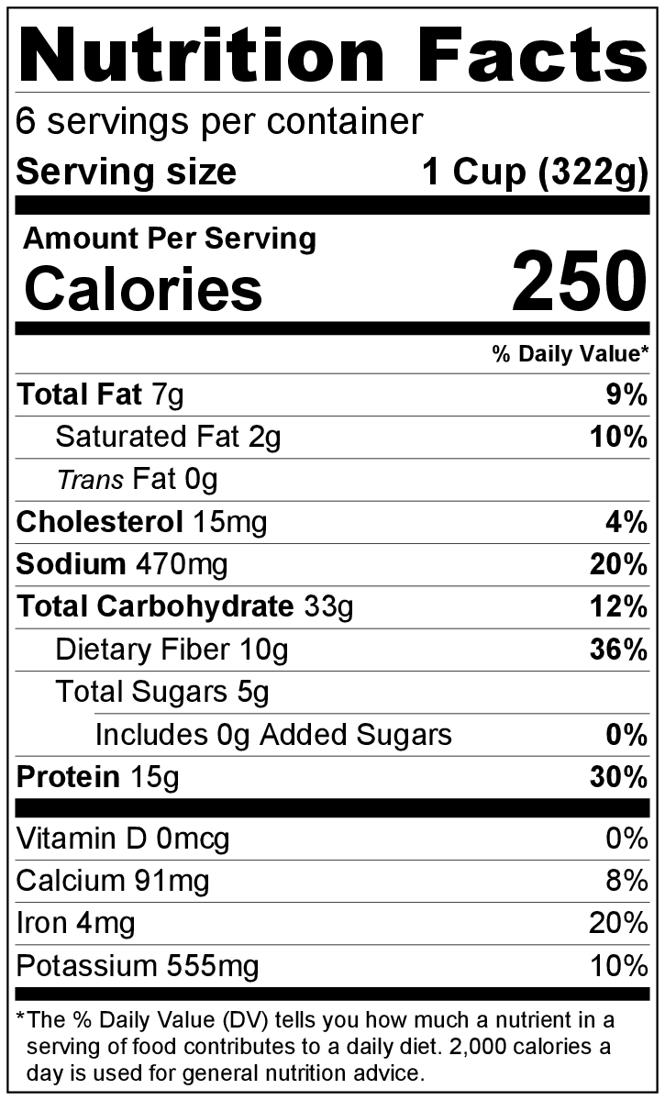
Makes: 6 servings (1 cup per serving)
Preparation Time: 10 minutes
Cooking Time: 30 minutes

Ingredients
1 tablespoon vegetable oil
1 medium onion, chopped
⅛ teaspoon garlic powder
4 ounces deli ham, diced
½ pound collard greens, stems removed and chopped*
1 (14.5 ounce) can broth (chicken or vegetable)
2 (15 ounce) cans black-eyed peas, drained and rinsed
½ to 1 cup water
2 teaspoons apple cider vinegar
Salt and black pepper to taste

Directions
- Wash the collard greens.*
- Drain and rinse the black-eyed peas.
- Collect, chop, dice, and measure all ingredients before starting to prepare the recipe.
- Place oil, onion, garlic, and ham in a large pot with a lid over medium heat. Stir occasionally until onion is clear, about 3 to 5 minutes.
- Add collard greens and broth to the pot.
- Cover and simmer for about 20 minutes until the collard greens are tender.
- Place half of the black-eyed peas in a small bowl, and mash with a fork. Stir the mashed and whole peas into the soup.
- Add ½ cup of water. If thinner soup is desired, add another ½ cup of water. Simmer for another 5 minutes.
- Stir in vinegar just before serving.
- Taste, and add a small amount of salt and black pepper if desired.
- Refrigerate leftovers within 2 hours. Eat within 3 to 5 days.

* Preparing collard greens: First, remove any damaged outer leaves. Fill a large bowl with cold water, and dunk the greens. Swish them around for a few minutes to help loosen any dirt on the leaves. Pour out the dirty water and fill the bowl with clean water. Swish the leaves under the clean water again to remove any additional dirt. Continue this process until the water in the bowl remains clear. To cut collard greens, fold each leaf in half with the stem at the fold crease. Either cut or tear the stem off. Stack several leaves on top of each other and roll the leaves up. Cut the roll of leaves in 1 inch thick pieces.

Be Creative! Top with shredded cheese!

