Easy Marinara Sauce

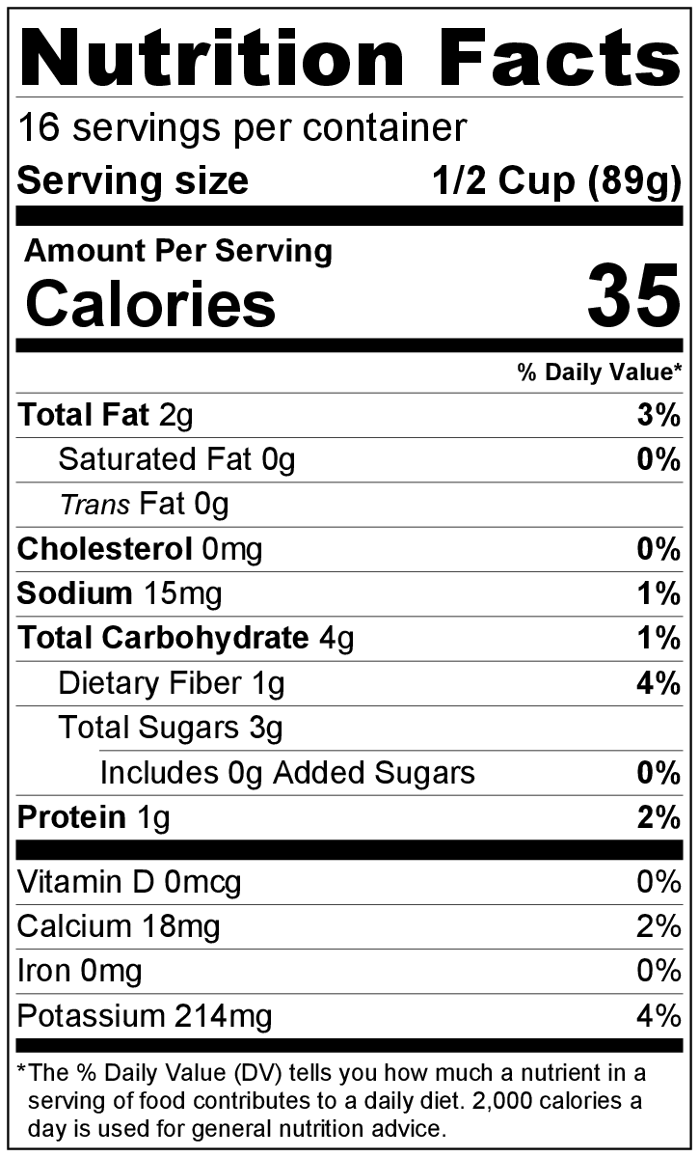
Makes: 16 servings (½ cup per serving)
Preparation Time: 10 minutes
Cooking Time: 45 minutes

Ingredients
2 tablespoons vegetable oil
2 onions, diced
½ teaspoon garlic powder
2 carrots, peeled and diced
¾ cup diced celery
2 (28 ounce) cans crushed tomatoes
1 tablespoon Italian seasoning
Salt and black pepper to taste
2 cups raw spinach, roughly chopped (optional)

Directions
- Wash the vegetables.
- Collect, dice, and measure all ingredients before starting to prepare the recipe.
- Heat the oil in a large pot over medium heat.
- Add the onion and garlic powder. Cook for about 10 minutes or until the onion is clear.
- Add the carrots and celery, and cook for 5 minutes until slightly soft.
- Add the tomatoes and Italian seasoning. Stir until all ingredients are mixed together. Taste, and add a little bit of salt and pepper if desired.
- Turn the heat up to medium high, and bring the sauce to a boil.
- Once boiling, reduce the heat to low. Simmer uncovered for at least 30 minutes.
- Stir in the spinach, and cook for 2 minutes until spinach wilts.*
- Refrigerate leftovers within 2 hours. Eat within 3 to 5 days.

* For a smoother sauce, blend in a blender or food processor.

Be creative! Use as sauce for pasta or as pizza sauce.

This recipe freezes well. Defrost in the refrigerator overnight, then reheat and eat!

