Enchilada Casserole

Makes: 8 servings (1½ cups per serving)
Preparation Time: 10 minutes
Cooking Time: 25 to 30 minutes

Ingredients
1 (28 ounce) can green enchilada sauce
1 (15 ounce) can pinto or black beans, drained and rinsed
3 cups cooked brown rice*
1 (15 ounce) can whole kernel corn, drained OR 1 ½ cups frozen corn
12 (6 inch) corn tortillas
10 ounces Monterey Jack or Cheddar cheese, shredded (2 ½ cups shredded)

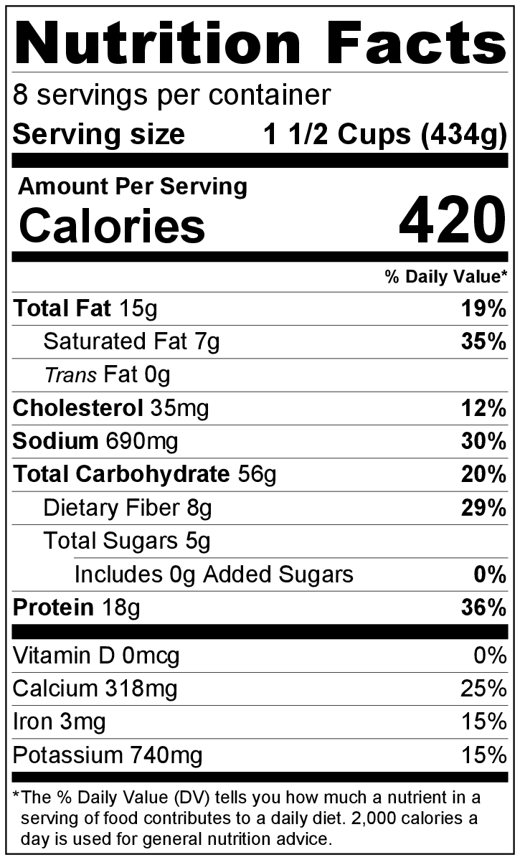
Directions
- Preheat oven to 350°F.
- Drain and rinse the beans and corn (if using canned corn).
- Collect and measure all ingredients before starting to prepare the recipe.
- In a large bowl, mix enchilada sauce, beans, cooked rice, and corn.
- Place half the mixture on the bottom of a 9 inch x 13 inch pan or split it between two 9 inch square or round pans.**
- Spread the corn tortillas evenly over the mixture. Place remaining mixture on top of tortillas.
- Top mixture with cheese, and cover with foil. Bake for 15 to 20 minutes.
- Remove foil, and bake for 10 more minutes or until cheese is melted and sauce is bubbly.
- Serve hot.
- Refrigerate leftovers within 2 hours. Eat within 3 to 5 days.

Be creative! Add leftover cooked meat and/or vegetables to the casserole layers.

* Cook rice according to package directions. The package will indicate how much uncooked rice is needed to make 3 cups of cooked rice.

** If you made two pans, you can freeze one of them before baking. Double-wrap in foil, and it will keep for up to 1 month in the freezer.

