Fried Rice with Chicken

Makes: 4 servings (1 ½ cups per serving)
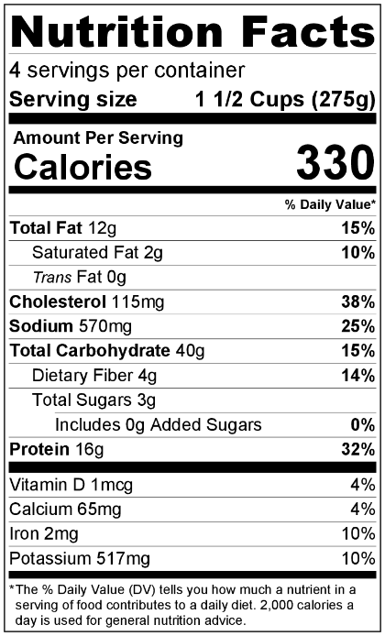
Preparation Time: 10 minutes
Cooking Time: 15 to 20 minutes

Ingredients
2 tablespoons vegetable oil
3 cups cooked and cooled brown rice*
1 carrot, peeled and diced
½ green pepper, diced
½ medium onion, diced
½ cup diced broccoli
2 tablespoons soy sauce
½ teaspoon black pepper
½ teaspoon garlic powder
2 eggs
¾ cup diced, cooked chicken or other meat*

Directions
- Wash all vegetables.
- Collect, dice, and measure all ingredients before starting to prepare the recipe.
- Heat oil in a large skillet over medium heat.
- Add cooked rice, and cook for 5 minutes, stirring regularly.
- Stir in carrot, green pepper, onion, broccoli, soy sauce, black pepper, and garlic powder. Cook until vegetables are tender, but still crisp.
- Remove rice and vegetable mixture from skillet. Put on a clean plate.
- Break 2 eggs into a small bowl, and beat with a fork.
- Reduce heat to medium low. Add the eggs to the skillet, and scramble.
- Once the eggs are cooked, add vegetables and rice back to the skillet, and mix. Add cooked chicken, and stir until thoroughly heated.
- Refrigerate leftovers within 2 hours. Eat within 3 to 5 days.

* This is a great recipe if you have leftover cooked rice or chicken. If you don’t have these on hand, cook them before starting the recipe. Cook the necessary amount of rice according to package directions. Cook ¾ cup of raw, small pieces of meat in 2 teaspoons of vegetable oil over medium heat until fully cooked.

Be Creative! Use any fresh, frozen, or cooked veggies. If you use cooked vegetables, add them in step #9

