Fruit Smoothie

Makes: 6 servings (1 cup per serving)
Preparation Time: 5 minutes

Ingredients
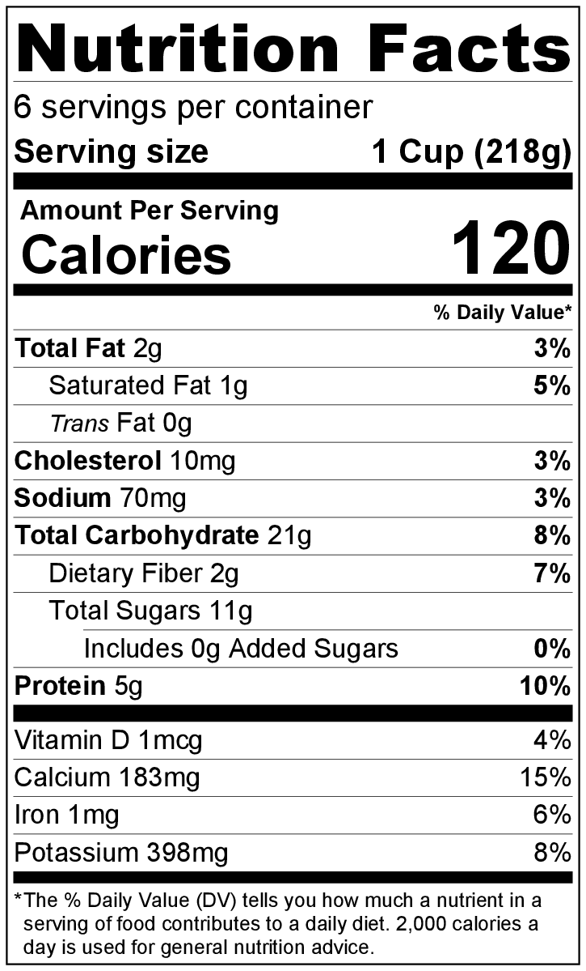
3 cups frozen strawberries or other frozen fruit
1 banana
1 cup yogurt (plain or vanilla)
1 handful of spinach or kale (optional)
2 cups milk

Directions
- Wash fresh produce.
- Collect and measure all ingredients before starting to prepare the recipe.
- Add the fruit, yogurt, and kale or spinach (if using) to the blender.
- Pour the milk into the blender.
- Blend for about 30 to 45 seconds until smooth.
- Refrigerate leftovers within 2 hours. Drink within 2 days.*

* These can also be made ahead of time and frozen. Thaw overnight in the refrigerator for a quick breakfast.

Be creative! Add any fresh or frozen fruit to the smoothie. If using only fresh fruit, you will need to add a few ice cubes before blending. Be sure to wash fresh fruit before using.

