Garden Vegetable Soup

Makes: 9 servings (1 cup per serving)
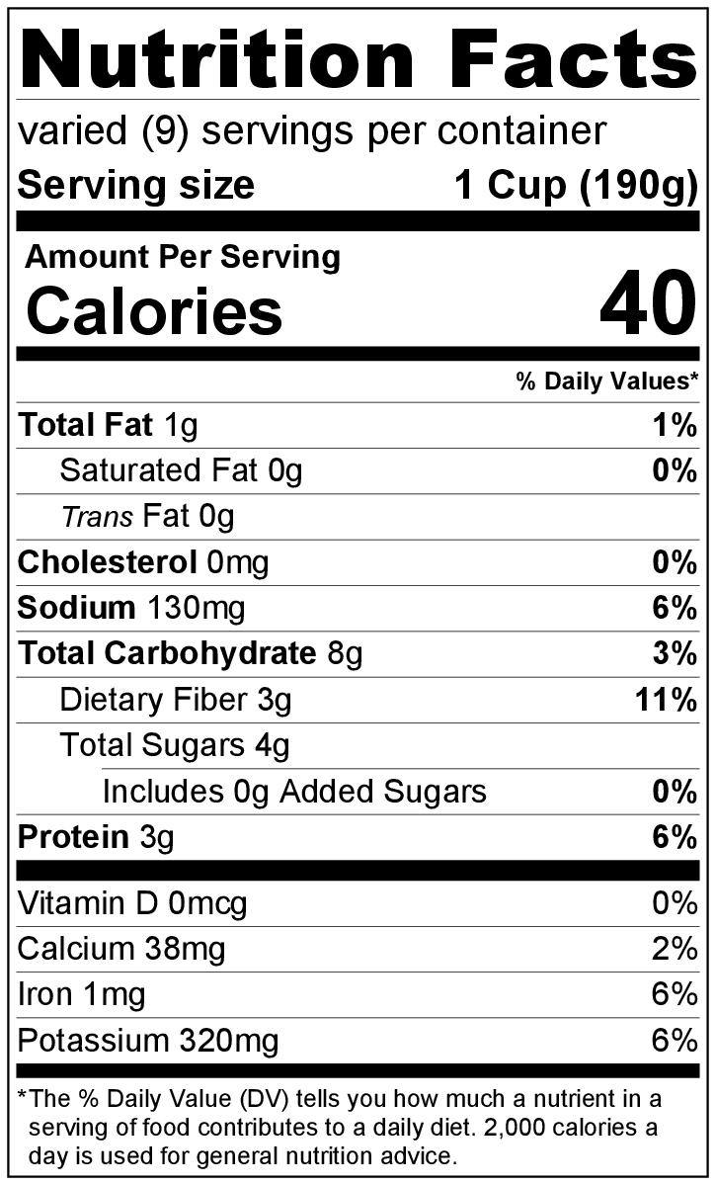
Preparation Time: 10 to 15 minutes
Cooking Time: 20 to 25 minutes

Ingredients
Nonstick cooking spray
2 carrots, peeled and chopped
1 large onion, chopped
2 (14.5 ounce) cans broth (chicken or vegetable)
1 cup chopped green cabbage
1 (14.5 ounce) can green beans, not drained
1 (14.5 ounce) can diced tomatoes, not drained
¼ teaspoon garlic powder
½ teaspoon Italian seasoning
1 medium zucchini, chopped
Salt and black pepper to taste

Directions
- Wash the vegetables.
- Collect, cut, and measure all ingredients before starting to prepare the recipe.
- Spray a large pot with nonstick cooking spray. Add the carrot and onion, and cook over low heat for about 5 minutes.
- Add broth, cabbage, green beans, tomatoes, garlic powder, and Italian seasoning. Turn the heat up to medium high, and bring to a boil.
- Reduce heat to low, and cover. Simmer for about 15 minutes or until carrots are tender. Stir in the zucchini, and cook for 3 to 4 minutes.
- Taste the soup. Add a small amount of salt and black pepper if desired.
- Remove from heat, and serve hot.
- Refrigerate leftovers within 2 hours. Eat within 3 to 5 days.

This recipe freezes well. Defrost in the refrigerator overnight, then reheat and eat!

Be creative! Try adding any canned or fresh vegetables.

