Healthy Refried Beans

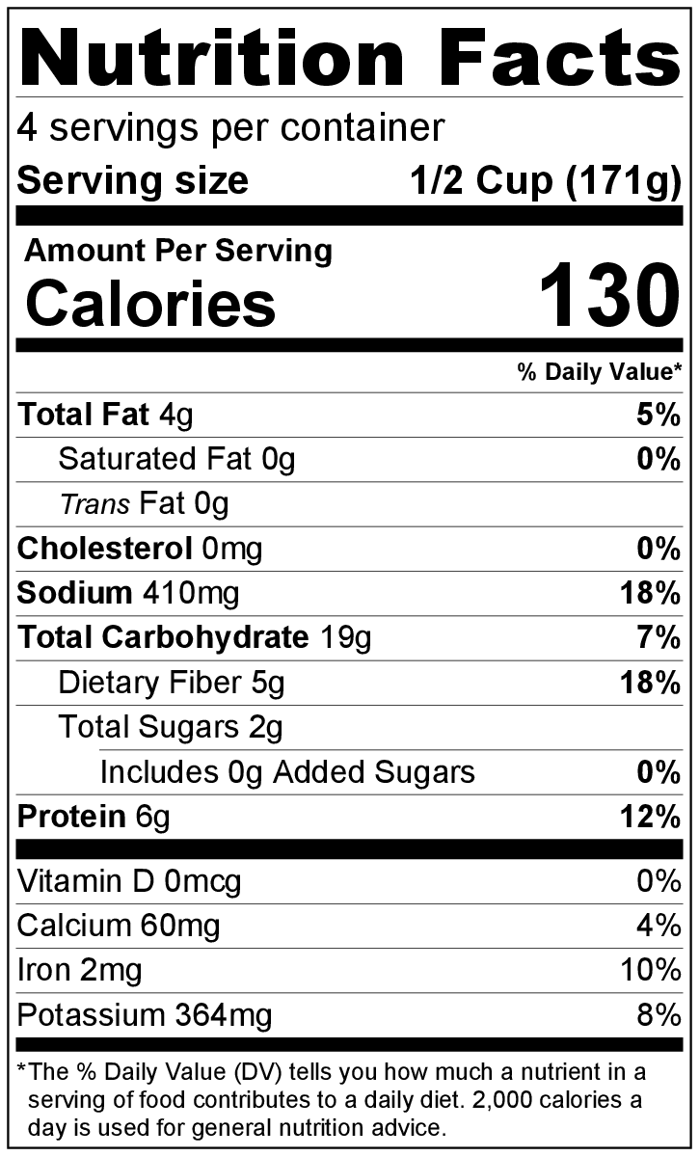
Makes: 4 servings (½ cup per serving)
Preparation Time: 5 minutes
Cooking Time: 10 minutes

Ingredients
1 tablespoon vegetable oil
½ medium onion, diced
⅛ teaspoon garlic powder
1 teaspoon chili powder
1 (15 ounce) can pinto beans, drained and rinsed
⅔ cup broth (chicken or vegetable)

Directions
- Collect, dice, and measure all ingredients before starting to prepare the recipe.
- Heat oil in a large skillet over medium heat. Add onion, and cook for about 3 minutes until the onion is soft.
- Stir in garlic powder and chili powder. Reduce heat to low.
- Add pinto beans and broth, and cook for 5 minutes.
- Mash beans with a potato masher or the back of a fork.
- Serve hot.
- Refrigerate leftovers within 2 hours. Eat within 3 to 5 days.

Be creative! Add to enchiladas or quesadillas. Serve as a side dish topped with fresh, washed, chopped cilantro and cheese or rolled into tortillas.

