Homemade Ranch Dressing

Makes: 16 servings (2 tablespoons per serving)
Preparation Time: 5 minutes
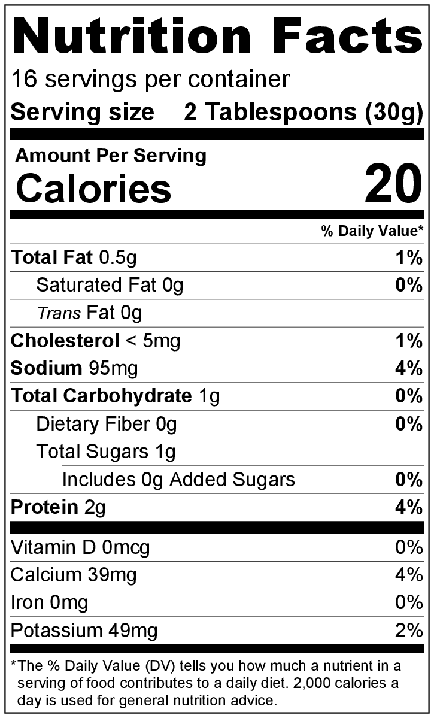
Ingredients
2 teaspoons dried, minced onion
½ teaspoon salt
⅛ teaspoon garlic powder
1 tablespoon dried parsley
1 cup plain Greek yogurt
1 cup buttermilk

Directions
- Collect and measure all ingredients before starting to prepare the recipe.
- Add the dried onion, salt, garlic powder, and dried parsley to a bowl, and stir gently to combine.
- Add the Greek yogurt and buttermilk, and stir until spices are evenly distributed.
- Chill before serving.
- Keep leftovers refrigerated, and eat within 1 week.

Be creative! To make a thicker ranch dip, substitute another cup of plain Greek yogurt for the buttermilk.

