Pasta Salad

Makes: 6 servings (1 cup per serving)
Preparation Time: 20 minutes
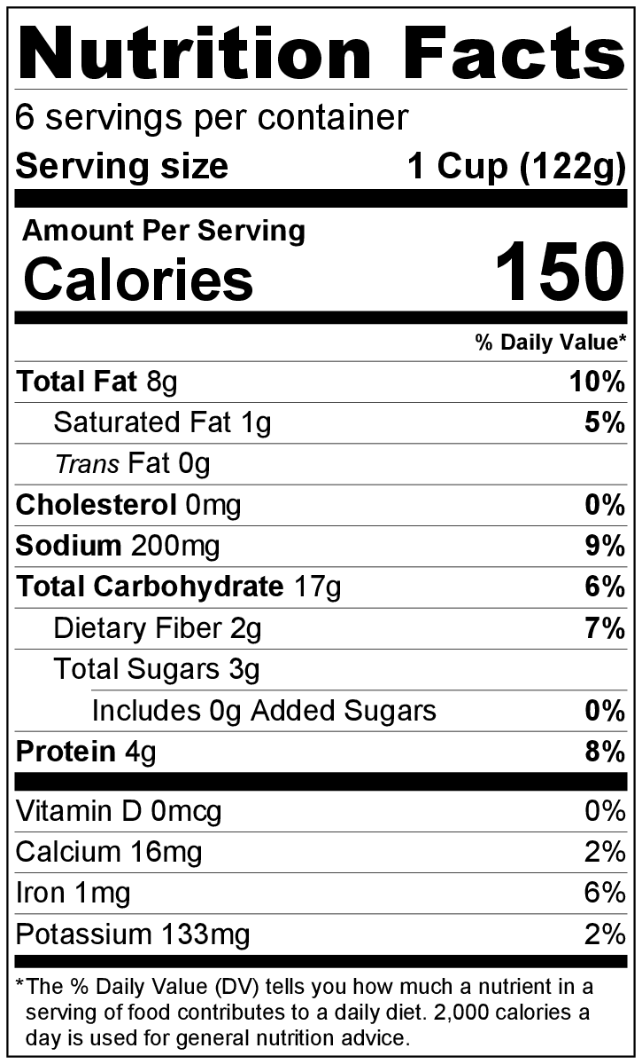
Ingredients
2 cups cooked pasta (any shape)
3 tablespoons vegetable oil
1 tablespoon apple cider vinegar
1 teaspoon salt
¼ teaspoon black pepper
½ teaspoon garlic powder
½ teaspoon Italian seasoning
1 pinch of crushed red pepper flakes (optional)
1 cup diced cucumber
1 large tomato, seeds removed and chopped*
½ green pepper, diced
1 small onion, minced
½ cup frozen peas, thawed

Directions
- Cook the pasta, drain, and cool in the refrigerator.
- Wash all vegetables, and remove seeds from tomato.*
- Collect, dice, and measure all ingredients before starting to prepare the recipe.
- Whisk together oil, vinegar, salt, black pepper, garlic powder, Italian seasoning, and crushed red pepper flakes (if using) in a large bowl.
- Add the pasta, cucumber, tomato, green pepper, onion, and peas.
- Mix all ingredients together until the vegetables and pasta are evenly coated.
- Serve immediately. It tastes even better when refrigerated for at least an hour. Cover when storing in the fridge, and stir again before serving.
- Refrigerate leftovers within 2 hours. Eat within 3 to 5 days.

* Removing tomato seeds: Turn the tomato on its side so the stem faces to the right. Cut the tomato down the center, and use a ¼ teaspoon to spoon out the seeds.

Be creative! Use whole wheat pasta.

