Rice Salad
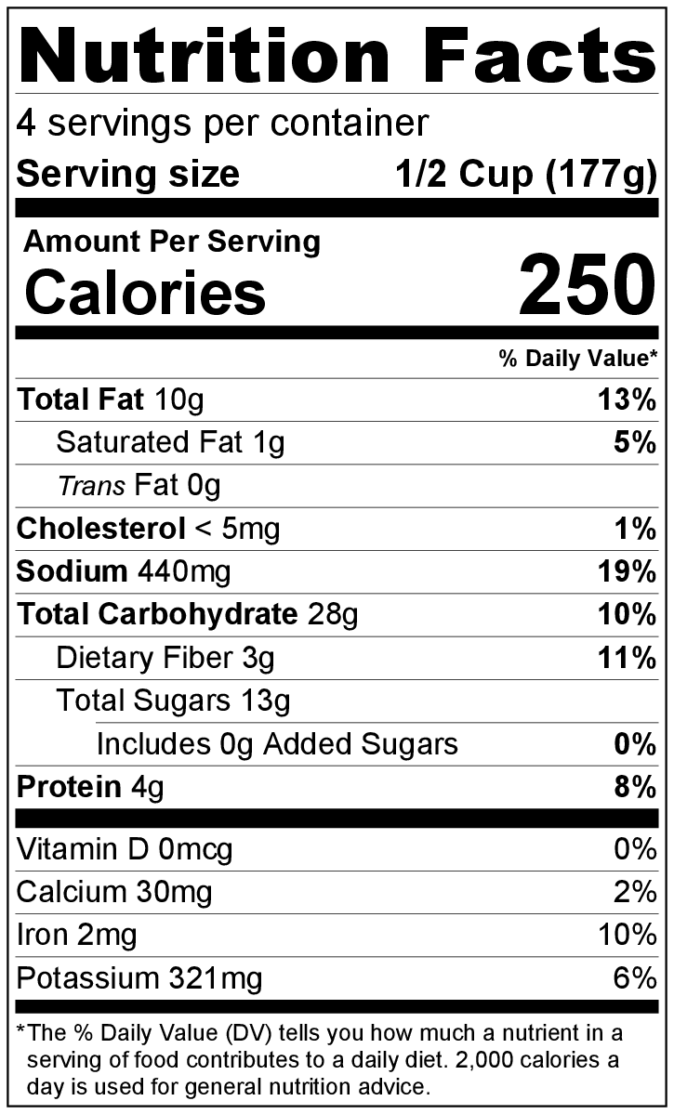
Makes: 4 servings (½ cup per serving)
Preparation Time: 10 minutes

Ingredients
2 tablespoons mayonnaise
2 tablespoons French dressing
½ teaspoon salt
2 cups cooked brown rice, chilled*
½ cup frozen green peas, thawed
½ cup diced celery
½ green pepper, diced
¼ cup raisins

Directions
- Wash all fresh vegetables.
- Collect, dice, and measure all ingredients before starting to prepare the recipe.
- Mix mayonnaise, French dressing, and salt in a large bowl. Add chilled rice, peas, celery, green pepper, and raisins. Mix well.
- Cover and refrigerate for one hour. Serve cold.
- Refrigerate leftovers within 2 hours. Eat within 3 to 5 days.

Be creative! Add any washed fresh, frozen (thaw first), or canned vegetables to the salad.

* Cook rice according to package directions. The package will indicate how much uncooked rice is needed to make 2 cups of cooked rice.

