Salmon Patties

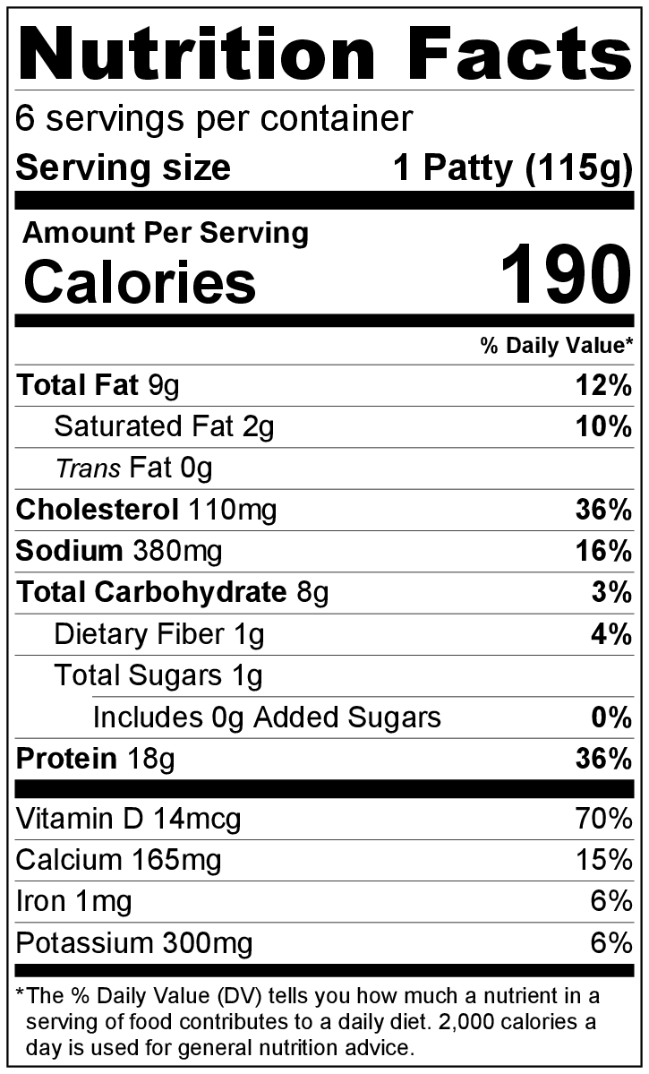
Makes: 6 servings (1 patty per serving)
Preparation Time: 10 minutes
Cooking Time: 5 to 10 minutes

Ingredients
1 (14.75 ounce) can salmon*
1 tablespoon lemon juice
Cold water
¼ cup minced celery (optional)
1 tablespoon minced green pepper (optional)
½ medium onion, minced
2 large eggs
⅓ cup bread crumbs or cracker crumbs
2 tablespoons all-purpose flour
⅛ teaspoon black pepper
1 tablespoon vegetable oil

Directions
- Wash fresh vegetables (if using).
- Collect, mince, and measure all ingredients before starting to prepare the recipe.
- Open salmon, and drain liquid into a liquid measuring cup. Add lemon juice and cold water to the salmon liquid to make ½ cup liquid total, and set aside.
- Put the salmon in a separate mixing bowl. Mix in the celery (if using), green pepper (if using), and onion.
- In another small bowl, beat the eggs. Then, add them to the salmon mixture.
- Add the bread or cracker crumbs, flour, pepper, and the salmon liquid mixture to the salmon mixture, and stir until all ingredients are mixed together.
- Use ⅓ cup measuring cup to measure salmon mixture. Shape into a ½ inch thick patty, and place on a plate. Repeat to make 6 patties.
- Heat the oil in a skillet over medium heat, then add 3 patties.
- Cook for about 2 to 3 minutes (or until golden brown) on each side.
- Remove patties from skillet, and place on a clean paper towel-lined plate to drain. Cook remaining 3 patties, then serve immediately.
- Refrigerate leftovers within 2 hours. Eat within 3 to 5 days.

* Use canned salmon with bones to get extra calcium.

Be creative! Top with salsa or pico de gallo.

