Summer Italian Vegetables

Makes: 6 servings (½ cup per serving)
Preparation Time: 10 minutes
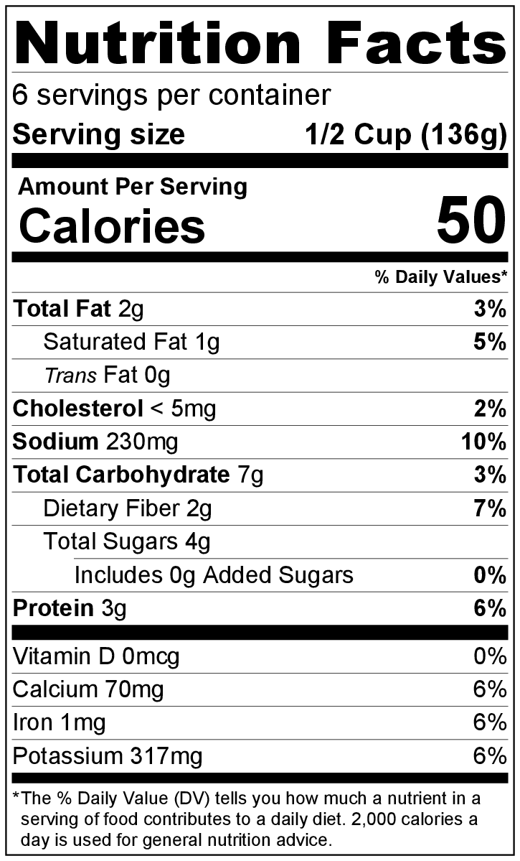
Cooking Time: 35 to 40 minutes

Ingredients
1 medium onion, diced
1 medium yellow squash or zucchini, chopped
1 tomato, chopped
1 green pepper, diced
1 (8 ounce) can tomato sauce
1 teaspoon Italian seasoning
½ teaspoon garlic powder
2 ounces of mozzarella cheese, shredded (½ cup shredded)
Salt and black pepper to taste

Directions
- Preheat oven to 350°F.
- Wash all vegetables.
- Collect, chop, shred, and measure all ingredients before starting to prepare the recipe.
- Combine onion, squash or zucchini, tomato, and green pepper in a 9 inch square baking dish.
- In a small bowl, mix the tomato sauce, Italian seasoning, and garlic powder together, then pour the sauce over the vegetables.
- Bake uncovered for 30 to 35 minutes until squash/zucchini is tender.
- Top with cheese, and bake another 4 to 5 minutes until cheese is melted.
- Remove from oven and let stand for 5 minutes before serving.
- Refrigerate leftovers within 2 hours. Eat within 3 to 5 days.

Be creative! Make it a meal by adding seasoned, cooked ground beef, chicken, or turkey.

