Tuna Salad

Makes: 7 servings (½ cup per serving)
Preparation Time: 15 minutes

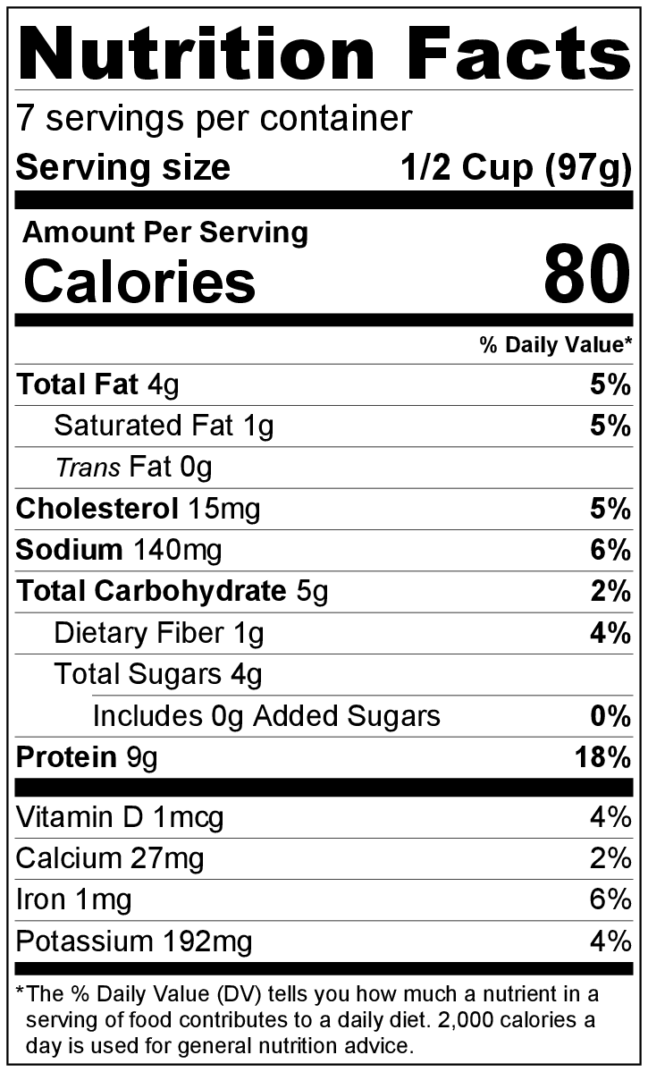
Ingredients
2 (5 ounce) cans tuna, drained
1 cup minced celery
2 tablespoons mayonnaise
2 tablespoons plain yogurt
1 cup seedless grapes, cut in half
Lettuce leaves, washed and separated

Directions
- Wash celery, grapes, and lettuce.
- Collect, chop, and measure all ingredients before starting to prepare the recipe.
- Stir together tuna, celery, mayonnaise, and yogurt in a bowl.
- Add grapes to mixture, and stir gently.
- Cover and chill until ready to serve.
- Serve on lettuce leaves.
- Refrigerate leftovers within 2 hours. Eat within 3 to 5 days.

Be creative! Try apples or mandarin oranges instead of grapes, add shredded carrots, or serve on crackers, tortillas, or bread.

