Vegetables and Creamy Dip

Makes: 12 servings (½ cup vegetables and 2 tablespoons of dip per serving)
Preparation Time: 10 to 15 minutes

Ingredients
6 cups washed, cut, fresh vegetables such as broccoli, cauliflower, carrots, celery, jicama, bell pepper, or cucumber
2 cups cottage cheese
½ teaspoon salt
¼ teaspoon black pepper
½ teaspoon garlic powder
2 tablespoons dried, minced onion
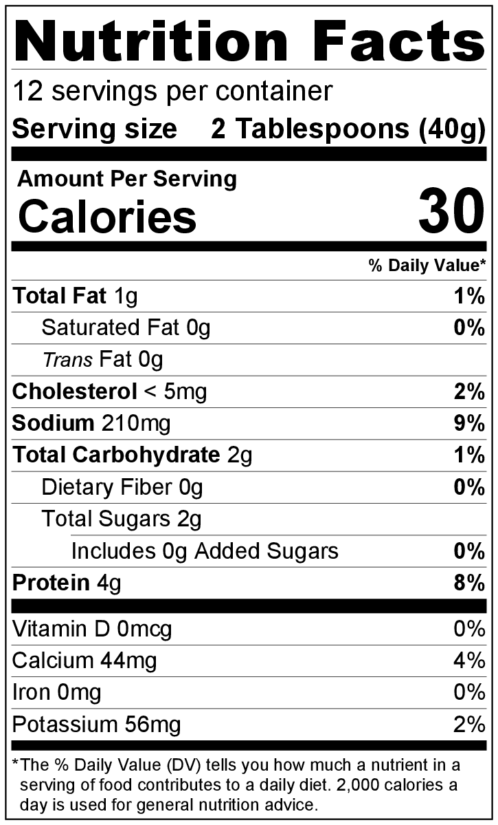
1 tablespoon dried parsley flakes
Dip only
½ teaspoon dried dill weed (optional)

Directions
- Wash vegetables, and slice them into pieces that are easy to dip.
- Collect and measure all ingredients before starting to prepare the recipe.
- Combine cottage cheese, salt, pepper, garlic powder, dried onion, dried parsley, and dried dill (if using) in a medium bowl. Mix until smooth.
- Chill dip in refrigerator until ready to serve. Making in advance will improve the flavor.
- Serve with vegetables arranged on a plate around a bowl of the dip.
- Refrigerate leftovers within 2 hours. Eat within 3 to 5 day.

