Vinaigrette Dressing Variations
Basic Vinaigrette
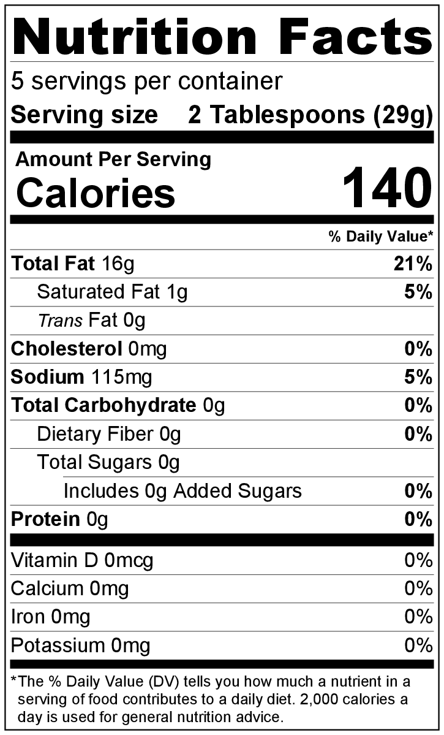
Makes: 5 servings (2 tablespoons per serving)
Preparation Time: 5 minutes

Ingredients
Try these combinations, or create your own!

Basic Vinaigrette:
6 tablespoons oil
4 tablespoons apple cider vinegar
¼ teaspoon salt
¼ teaspoon black pepper

Italian Vinaigrette: add these ingredients to the Basic Vinaigrette
Italian Vinaigrette
1 teaspoon garlic powder
1 teaspoon Italian seasoning
1 pinch of crushed red pepper flakes (optional)

Honey Mustard Vinaigrette: add these ingredients to the Basic Vinaigrette
1 teaspoon Dijon or spicy brown mustard
2 teaspoons honey

Directions
- Collect and measure all ingredients.
- Combine all ingredients in a small container with a lid and shake well, or combine in a small bowl and whisk until smooth.
- Allow to stand for 10 minutes so flavors blend together.
Honey Mustard Vinaigrette
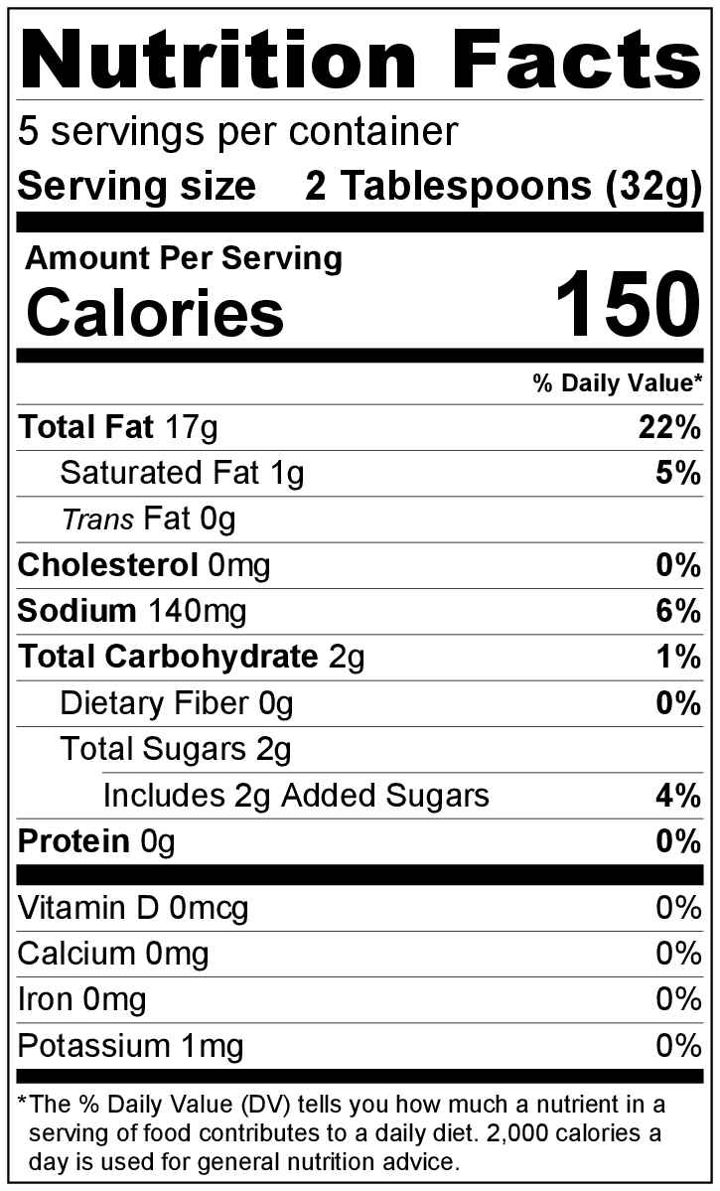
- Store for up to 2 weeks in a sealed container in the refrigerator.
- Contents may separate when stored. Shake or stir to re-mix before using.

