Collard Greens
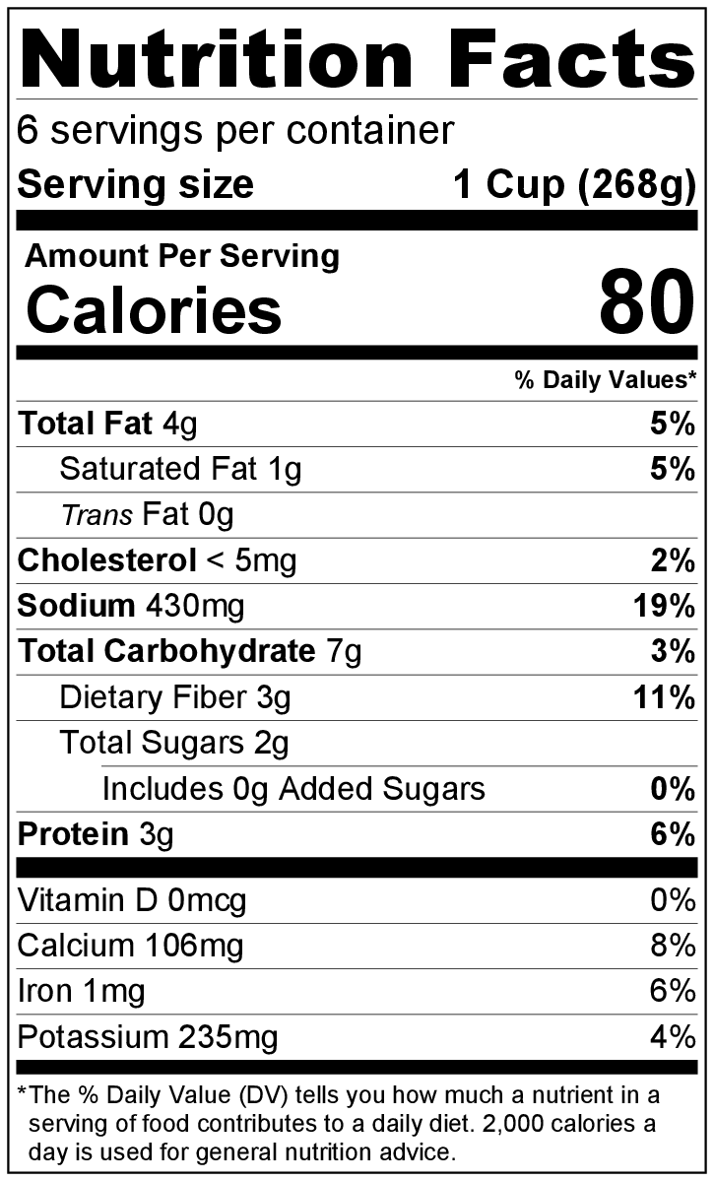
Makes: 6 servings (1 cup per serving)
Preparation Time: 15 minutes
Cooking Time: 45 minutes

Ingredients
1 tablespoon vegetable oil
1 tablespoon butter
½ medium onion, chopped
½ teaspoon red pepper flakes (increase to 1 teaspoon if you like food spicy)
⅛ teaspoon garlic powder
1 pound collard greens, stems removed and chopped*
3 cups broth (chicken or vegetable)
2 tomatoes, seeds removed and chopped**
Salt and black pepper to taste

Directions
- Wash all vegetables,* and remove seeds from the tomatoes.**
- Collect, chop, and measure all ingredients before starting to prepare the recipe.
- Heat the oil and butter in a large pot over medium heat.
- Add the onion, and cook for about 2 minutes until slightly soft.
- Add the red pepper flakes and garlic, and cook for 1 minute. Add the chopped collard greens, and cook for another minute.
- Add the broth, cover, and bring to a simmer. Cook for about 40 minutes until the greens are tender.
- Add the tomatoes.
- Taste, and add a small amount of salt and black pepper if desired.
- Serve hot.
- Refrigerate leftovers within 2 hours. Eat within 3 to 5 days.

* Preparing collard greens: First, remove any damaged outer leaves. Fill a large bowl with cold water, and dunk the greens. Swish them around for a few minutes to help loosen any dirt on the leaves. Pour out the dirty water and fill the bowl with clean water. Swish the leaves under the clean water again to remove any additional dirt. Continue this process until the water in the bowl remains clear. To cut collard greens, fold each leaf in half with the stem at the fold crease. Either cut or tear the stem off. Stack several leaves on top of each other and roll the leaves up. Cut the roll of leaves in 1 inch thick pieces.

** Removing tomato seeds: Turn the tomato on its side so the stem faces to the right. Cut the tomato down the center and use a ¼ teaspoon to spoon out the seeds.

