Apple Salad

Makes: 6 servings (½ cup per serving)
Preparation Time: 15 minutes
Chilling Time: 1 hour

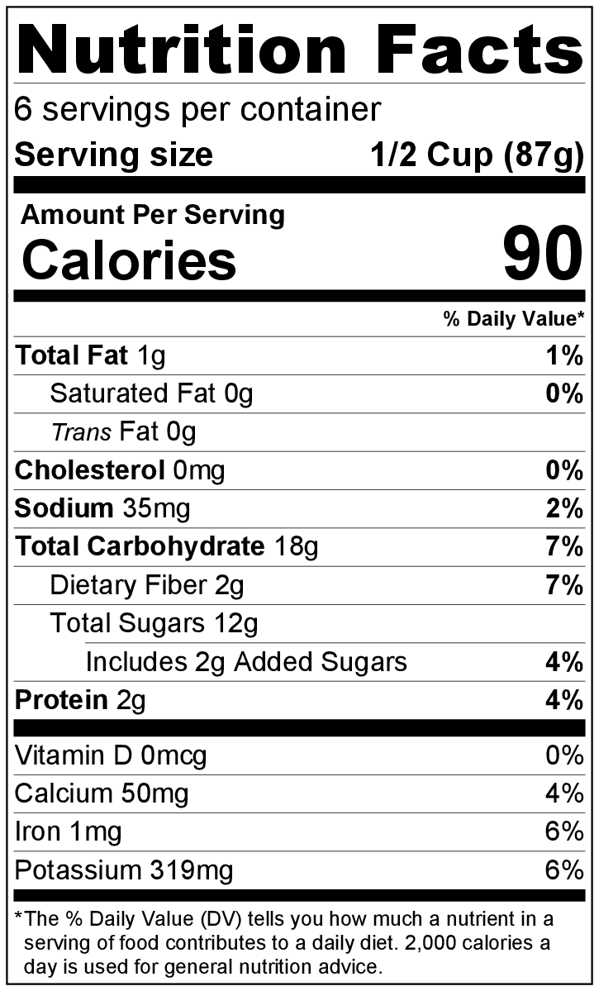
Ingredients
1 apple, diced
1 teaspoon lemon juice
½ cup diced celery
½ cup carrot, peeled and grated
½ cup raisins
½ cup (4 ounces) vanilla yogurt

Directions
- Wash the apple and vegetables.
- Collect, dice, grate, and measure all ingredients before starting to prepare the recipe.
- Toss apple with lemon juice in a bowl to prevent browning.
- Add celery, carrot, and raisins.
- Stir yogurt into the rest of the ingredients.
- Cover. Chill for at least 1 hour before serving to allow the flavors to mix together.
- Refrigerate leftovers within 2 hours. Eat within 3 to 5 days.

Be creative! Try adding ½ cup chopped walnuts, almonds, or pecans to the salad.

