Lentil Tacos

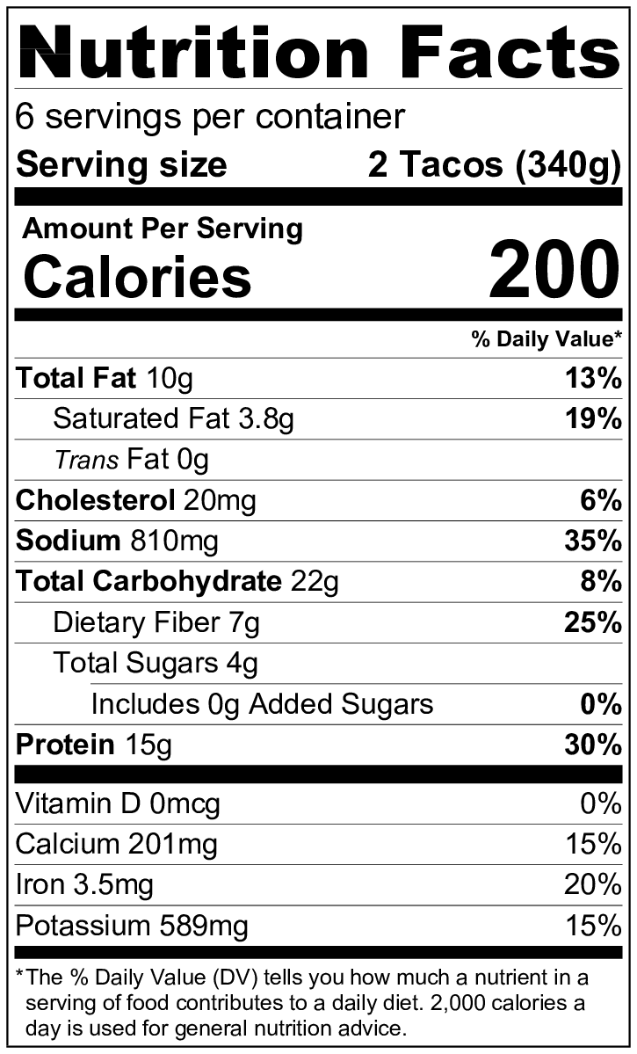
Makes: 6 servings (2 tacos per serving)
Preparation Time: 8 minutes
Cooking Time: 30 minutes

Ingredients
Nonstick cooking spray
1 tablespoon vegetable oil
1 medium onion, diced
1 cup dried lentils
¼ teaspoon garlic powder
2 tablespoons taco seasoning
3 cups water
1 (8 ounce) can tomato sauce
12 (6 inch) corn tortillas
1 cup salsa
4 ounces cheese, shredded (1 cup shredded)
2 cups shredded lettuce

Directions
- Wash the lettuce.
- Collect, dice, shred, and measure all ingredients before starting to prepare the recipe. Rinse the lentils.
- Spray a large skillet with cooking spray. Add tortillas to the skillet one at a time. Heat briefly on both sides over medium heat until warm and soft. Wrap in 2 layers of foil, put on a plate, and cover with another plate to keep warm.
- Heat the oil in the skillet over medium high heat.
- Add the onion, and cook for 4 to 6 minutes until it becomes soft. Stir while cooking.
- Add the lentils, garlic powder, and taco seasoning, and stir to mix.
- Add the water and tomato sauce, and stir to mix.
- Bring to a boil, then reduce heat to medium low, and cover. Cook for about 30 minutes or until the lentils are tender. Check and stir the mixture every 5 minutes to be sure the liquid is simmering and not boiling. If the mixture is boiling, reduce the heat to low. If there is no liquid, add a ½ cup more water, stir thoroughly and cover.
- Uncover, and cook for 5 more minutes until the mixture thickens, stirring every few minutes. (Optional: Mash the lentils somewhat with the back of a fork.)
- Add ¼ cup of the lentil mixture, salsa, cheese, and lettuce to each tortilla.
- Refrigerate leftovers within 2 hours. Eat within 3 to 5 days.

Be creative! Serve as lentil tostadas or with tortilla chips as a party dip.

