Oven-Fried Fish

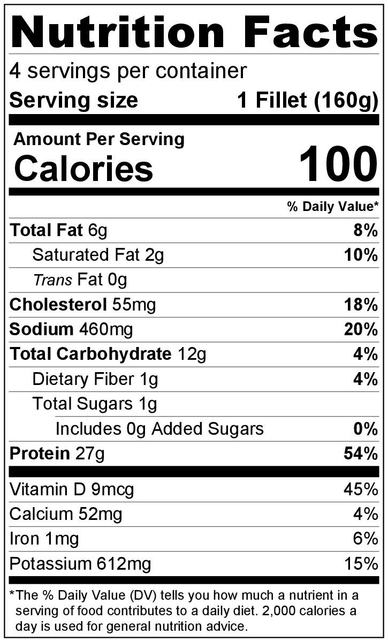
Makes: 4 servings (1 fillet per serving) Preparation Time: 10 minutes
Cooking Time: 15 to 20 minutes

Ingredients
1 egg, slightly beaten
½ teaspoon salt
½ teaspoon black pepper
½ cup bread crumbs
1 pound tilapia fillets, thawed (4 fillets)
1 tablespoon butter
1 fresh lime or lemon, sliced (optional)

Directions
- Preheat oven to 350°F.
- Wash the lime or lemon (if using).
- Collect, slice, and measure all ingredients before starting to prepare the recipe.
- In a small bowl, add egg, salt, and pepper, and beat together.
- Put bread crumbs in a separate small bowl.
- Dip fish fillets in the egg mixture, then dip in the bread crumbs to coat.
- Melt butter in a shallow 9 inch x 13 inch baking pan for 1 minute in the oven.
- Remove the pan from the oven, and tilt pan to coat with butter.
- Arrange fish fillets in the pan.
- Bake uncovered for 15 to 20 minutes or until fish flakes easily with a fork.
- Serve topped with lime or lemon slices (if using).
- Refrigerate leftovers within 2 hours. Eat within 3 to 5 days.

Be creative! Instead of breadcrumbs, use crushed, unsweetened cereal or crushed crackers.

