Zesty Bean Dip

Makes: 6 servings (⅓ cup per serving)
Preparation Time: 5 minutes

Ingredients
1 (16 ounce) can refried beans
½ cup salsa
3 tablespoons chopped fresh cilantro (optional)
½ small onion, minced (optional)
Crackers or Baked Tortilla Chips from the Eating Smart • Being Active Let’s Cook! cookbook

Directions
- Wash the cilantro (if using).
- Collect, mince, and measure all ingredients before starting to prepare the recipe.
- Combine all ingredients in a bowl.
- Serve with Baked Tortilla Chips from the Eating Smart • Being Active Let’s Cook! cookbook or whole wheat crackers.
- Refrigerate leftovers within 2 hours. Eat within 3 to 5 days.

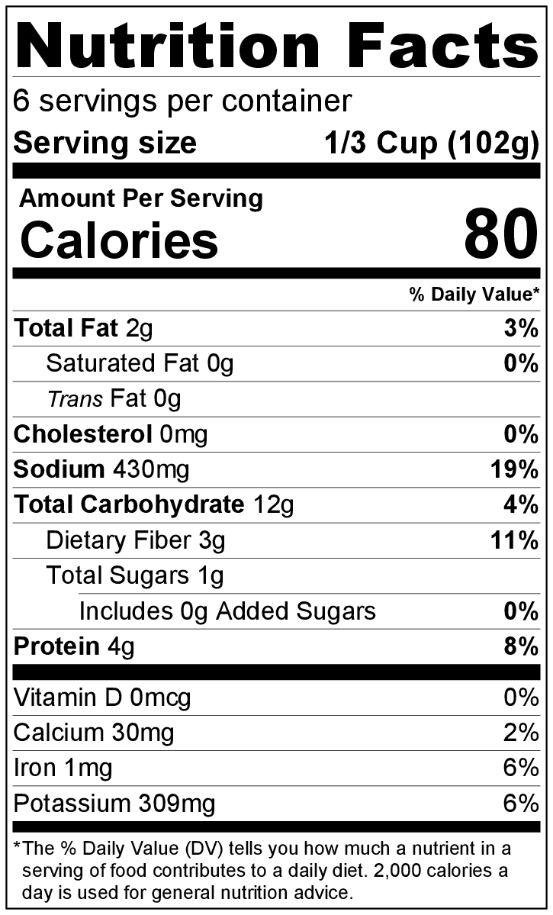
Be creative! Add minced green, red, or yellow bell pepper or diced jalapenos.

